**CRM APPLICATION FOR Medical Inventory Management**

**College Name :VET INSTITUTE OF ARTS AND SCIENCE**

**College Code:65651**

**Team ID: NM2025TMID25753**

**Team Size: 5**

**Team Leader: AATHI HARIHARA D**

**Team member: SARAVANAKUMAR E**

**Team member: GOKULSK**

**Team member: BHARANIDHARAN K**

**Team member: YOKESHWARAN P**

**Medical Inventory Management**

## **Creating Developer Account**

Creating a developer org in salesforce.

1. Go to <https://developer.salesforce.com/signup>
2. 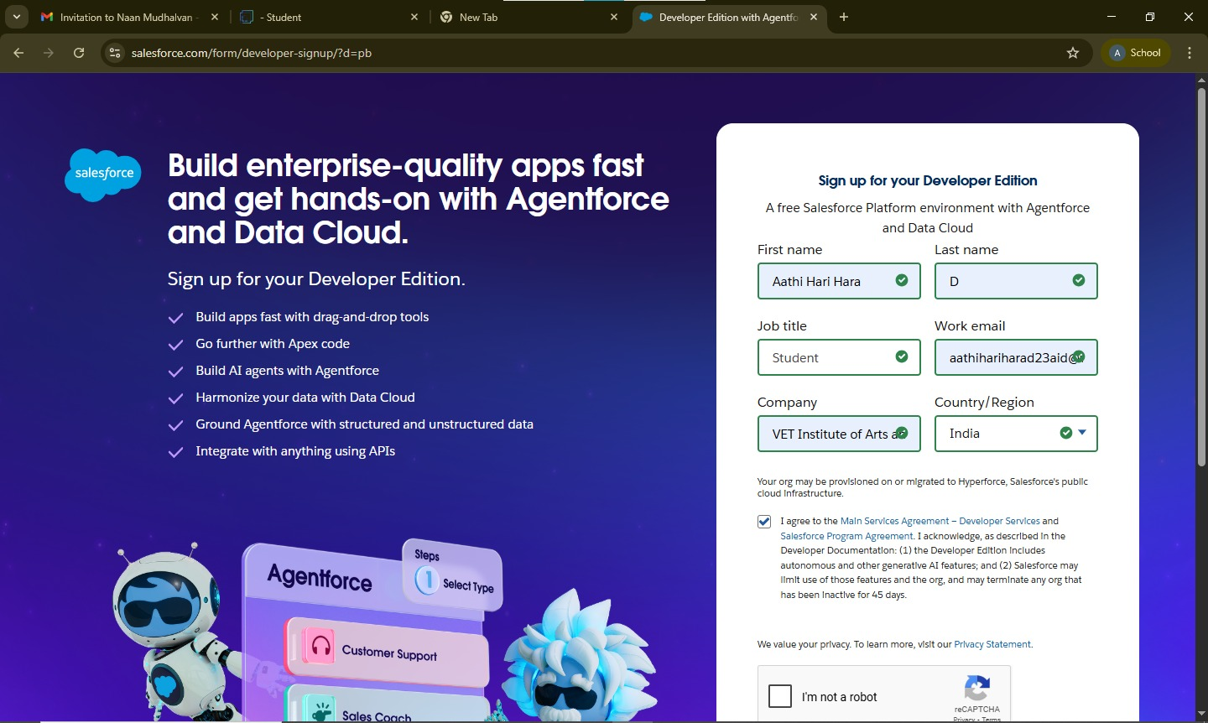On the sign up form, enter the following details :

1. First name & Last name

2. Email

1. Role : Developer
2. Company : College Name
3. County : India
4. Postal Code : pin code
5. Username : should be a combination of your name and company

This need not be an actual email id, you can give anything in the format : username@organization.com

Click on sign me up after filling these.

# Creating a Product Object

### To create an object:

1. From the setup page
2. Click on Object Manager
3. Click on Create >> Click on Custom Object.
4. Enter the label name as Product
5. Enter Plural label name as Products
6. Enter Record Name as Product ID
7. Select Data Type as Text.
8. Select Allow reports.
9. Select Allow search.
10. Click on Save and New

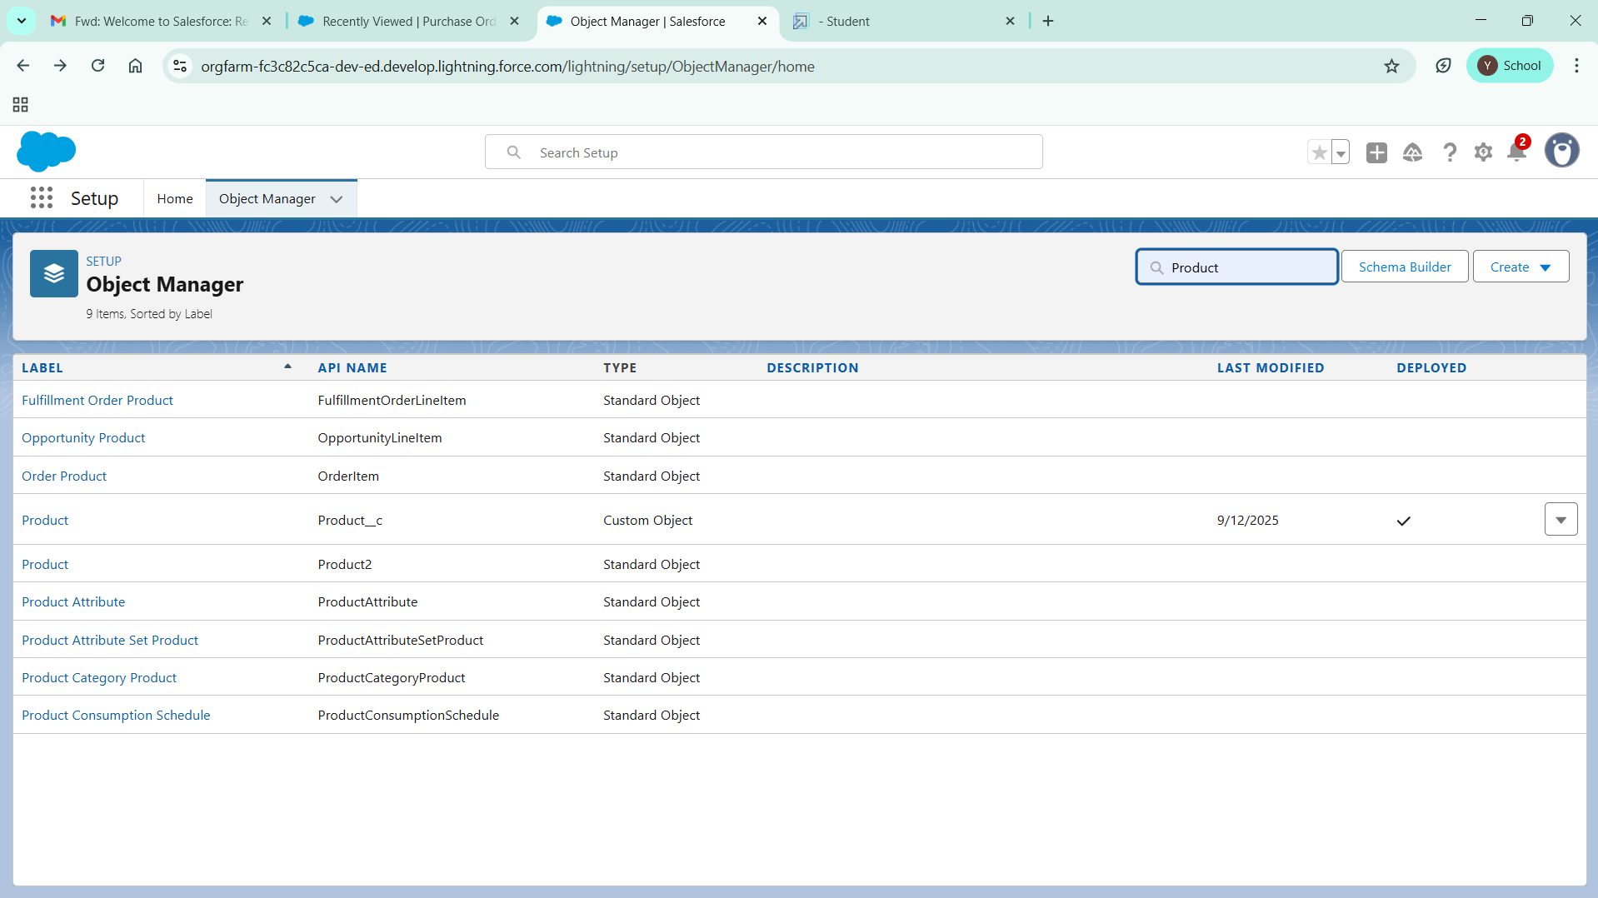

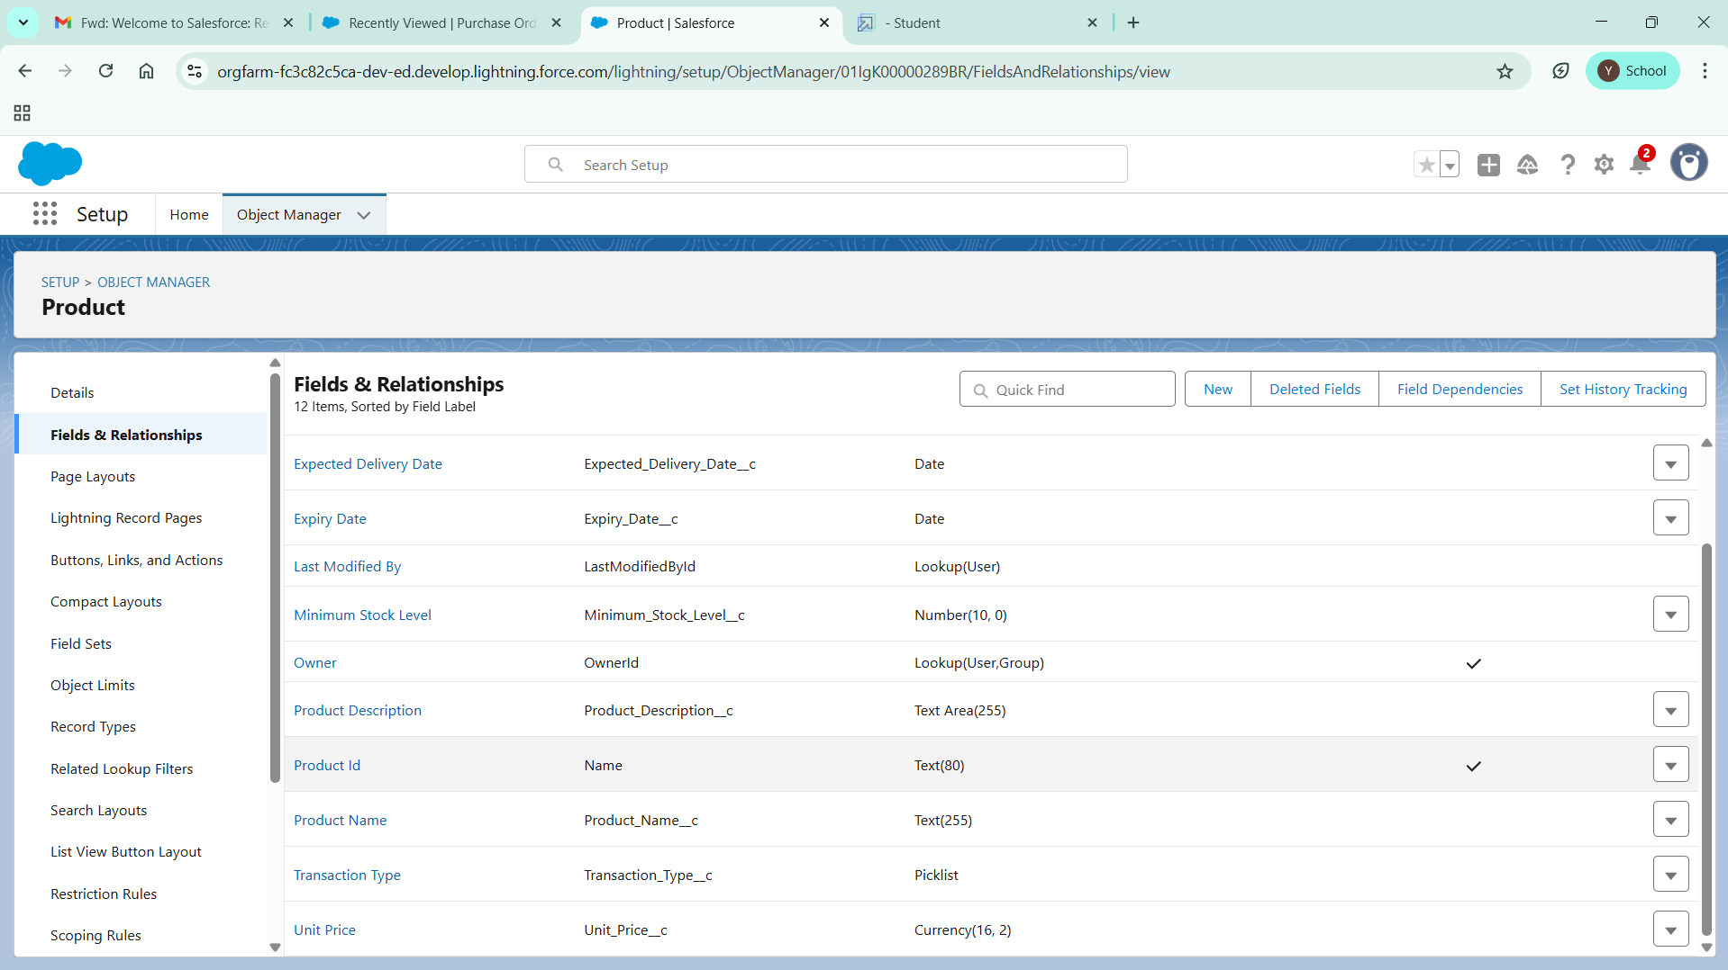

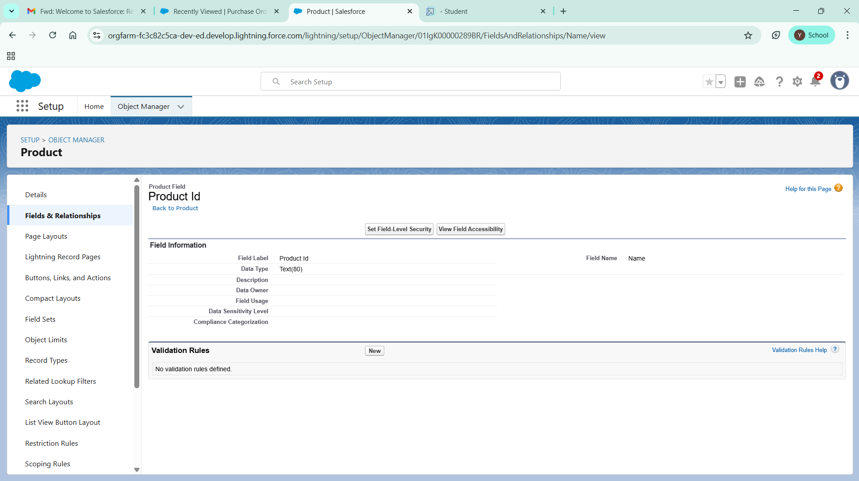

  In the same way Create Purchase Order, Order Item, Inventory Transaction and Supplier objects.

# Creating a tab for Product Object

1. Go to the setup page >> type Tabs in Quick Find bar
2. Click on tabs
3. Click on New (under custom object tab).
4. Select Object(Product) >> Select the tab style
5. Click on Next >> (Add to profiles page) keep it as default >> Click on Next (Add to Custom App)  uncheck the include tab .
6. Make sure that the Append tab to user’s existing personal customizations is checked.
7. Click save

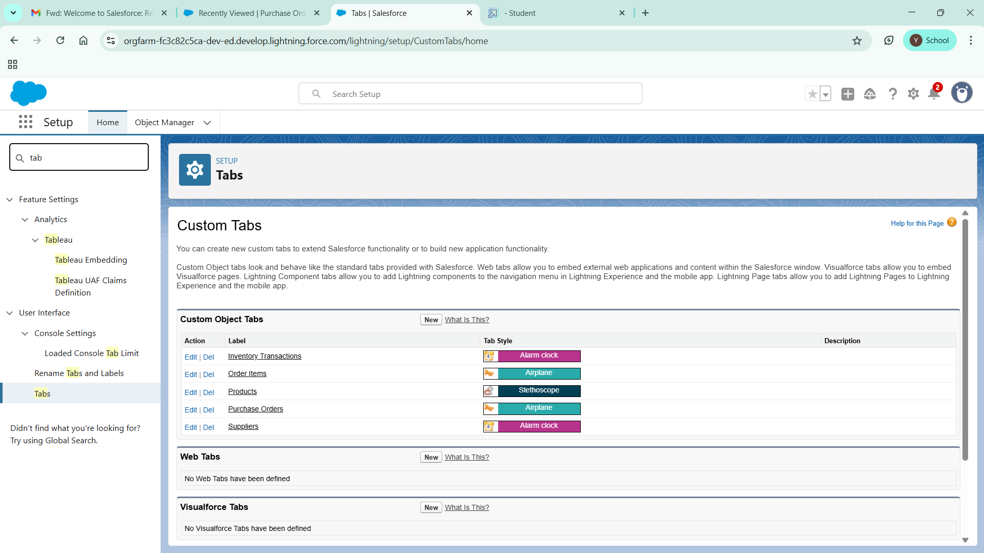

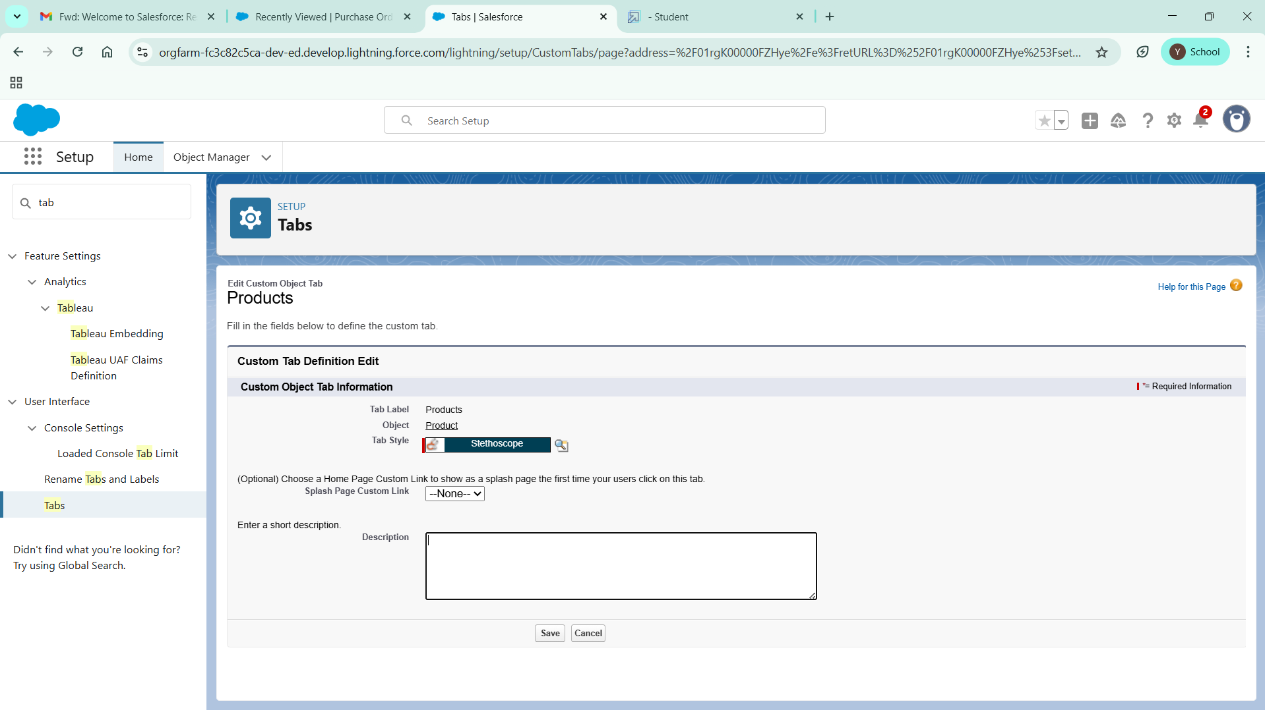

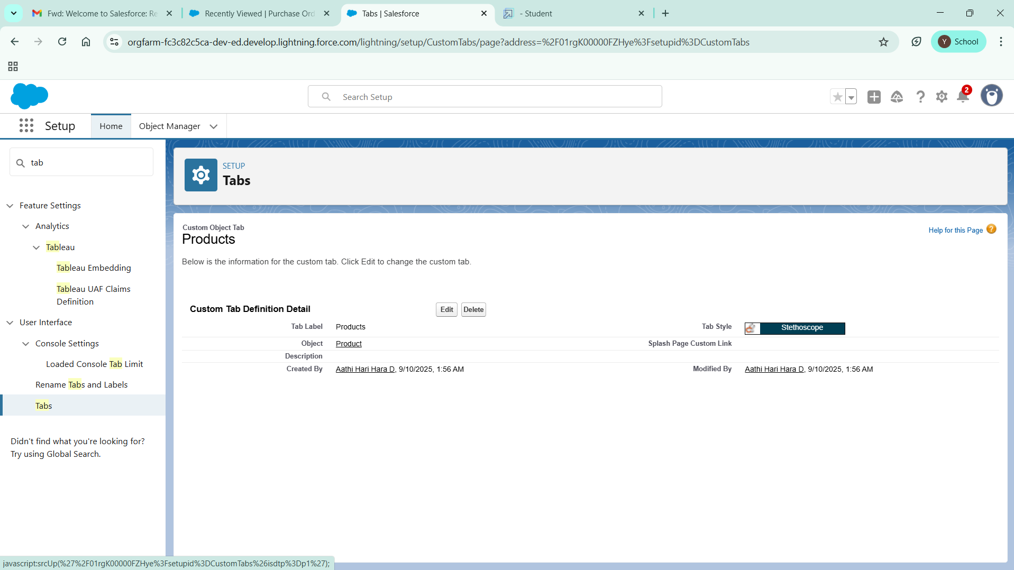

# **Creating Remaining Tabs**

1. Now create the Tabs for the remaining Objects, they are “Purchase Order, Order Item, Inventory Transaction, Supplier”.
2. Follow the same steps as mentioned in Activity -1 .

# **Create a Lightning App for Medical Inventory Management**

1. From Setup, enter App Manager in the Quick Find and select App Manager.
2. Click New Lightning App.
3. Enter Medical Inventory Management as the App Name >> Click on upload image and add an image related to Medical Inventory then click next
4. Under App Options, leave the default selections and click next.
5. Under Utility Items, leave as is and click Next.
6. From Available Items, select Products, Purchase Orders, Order Items, Inventory Transactions, Suppliers, Reports, and Dashboards and move them to Selected Item and Click Next.
7. From Available Profiles, select System Administrator and move it to Selected Profiles.
8. Click Save & Finish.

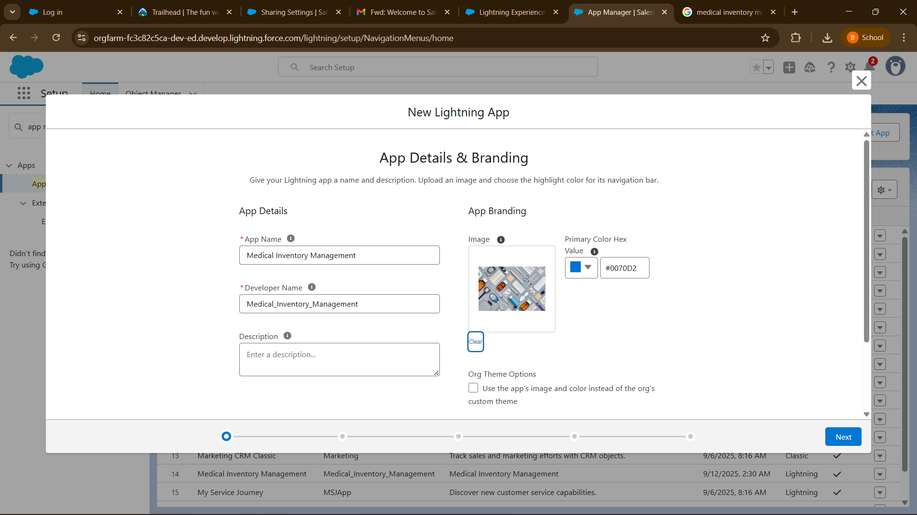

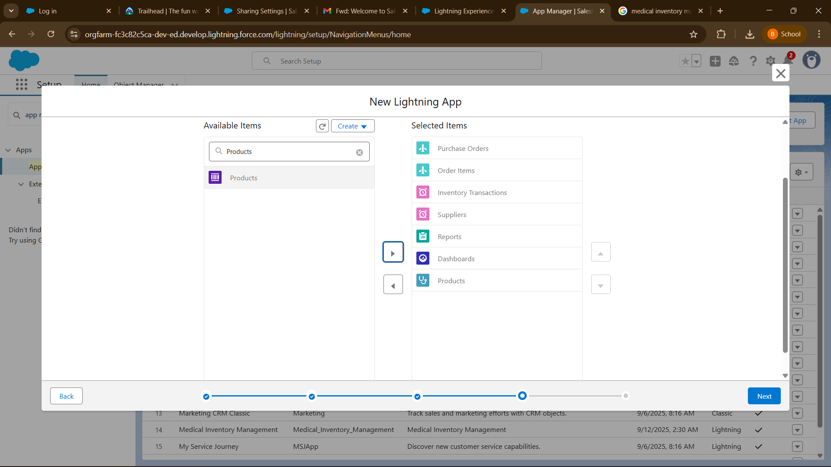

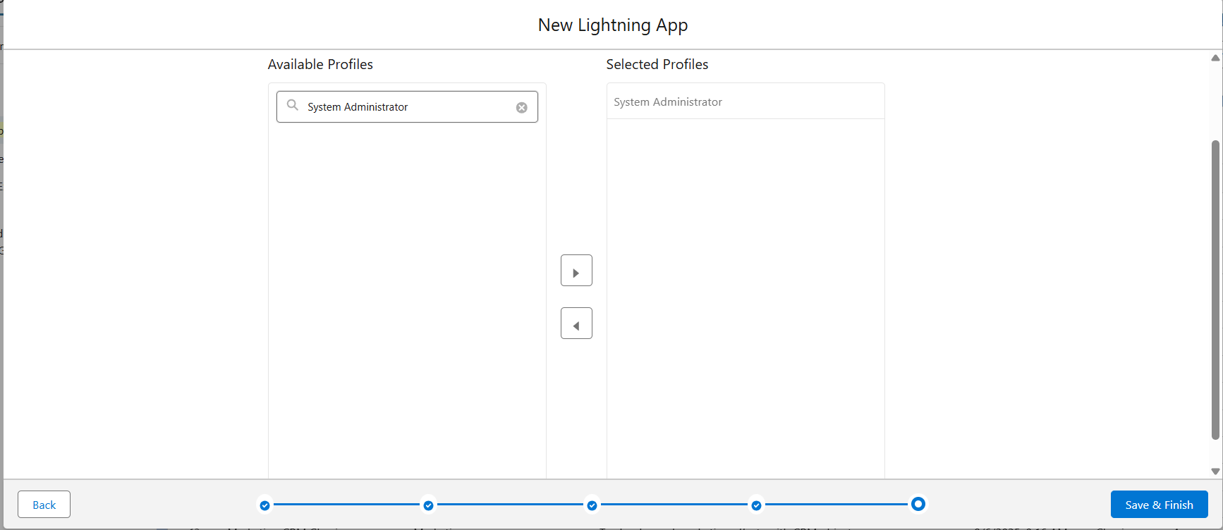

# **Creating a Text Field in Product Object**

### To create fields in an object:

1. Click the gear icon and select Setup. This launches Setup in a new tab.
2. Click the Object Manager tab next to Home.
3. Select Product custom object.
4. Select Fields & Relationships from the left navigation
5. Click on New
6. Select Text field, click Next
7. Enter Field Label as “Product Name” and Length 255.
8. Select Required Field.
9. Click Next, Next, then Save & New.

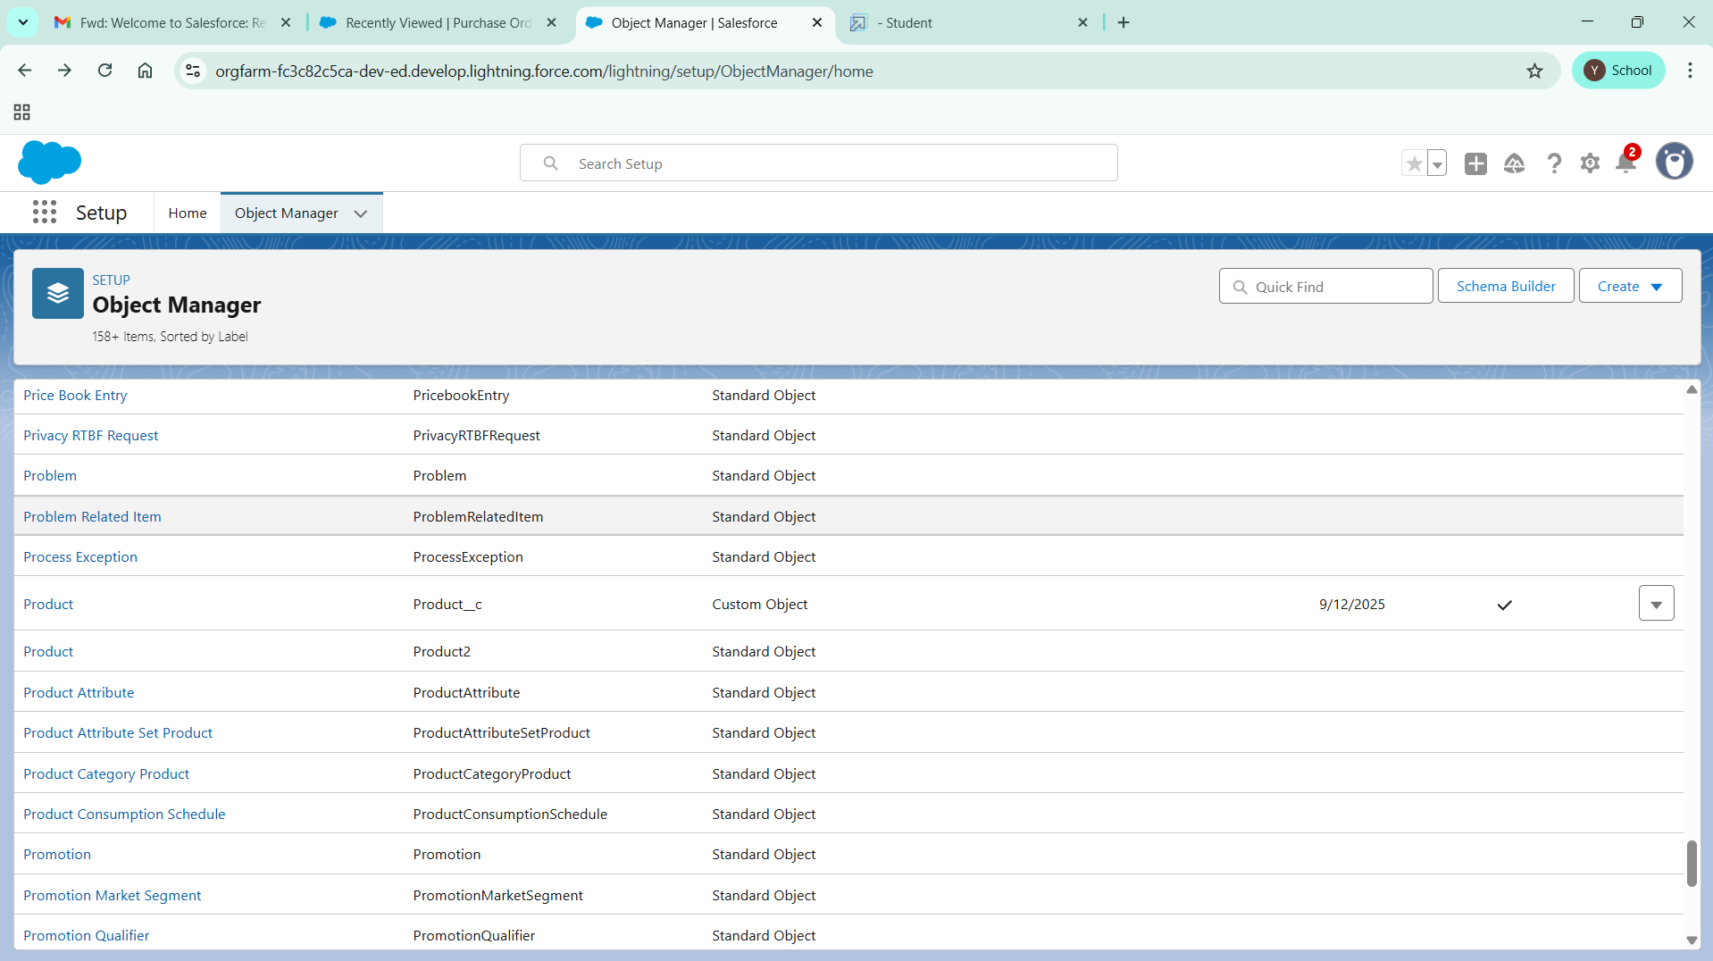

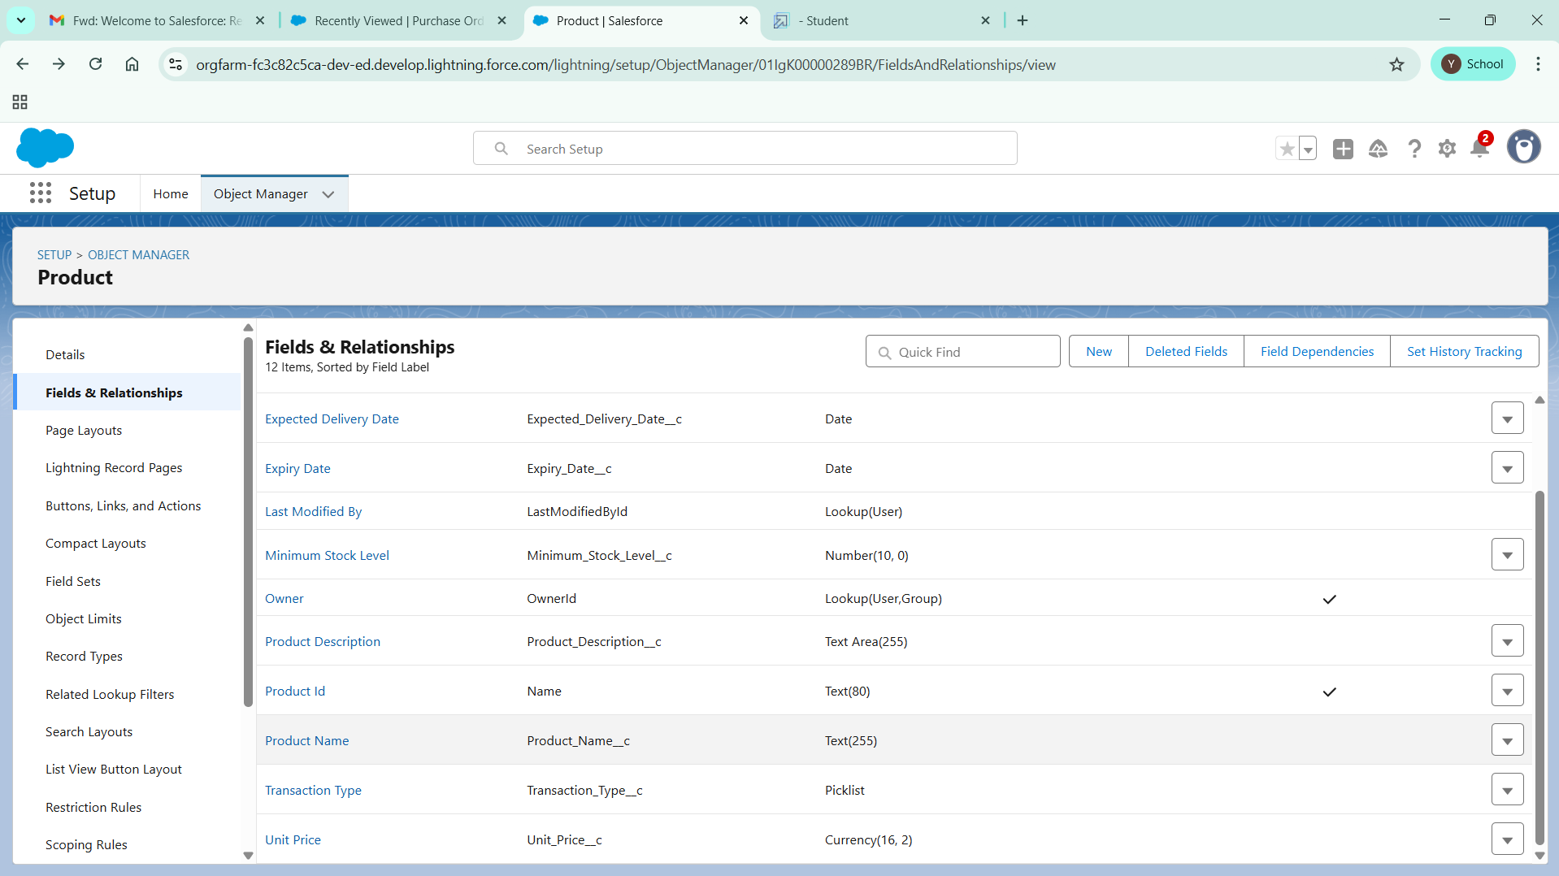

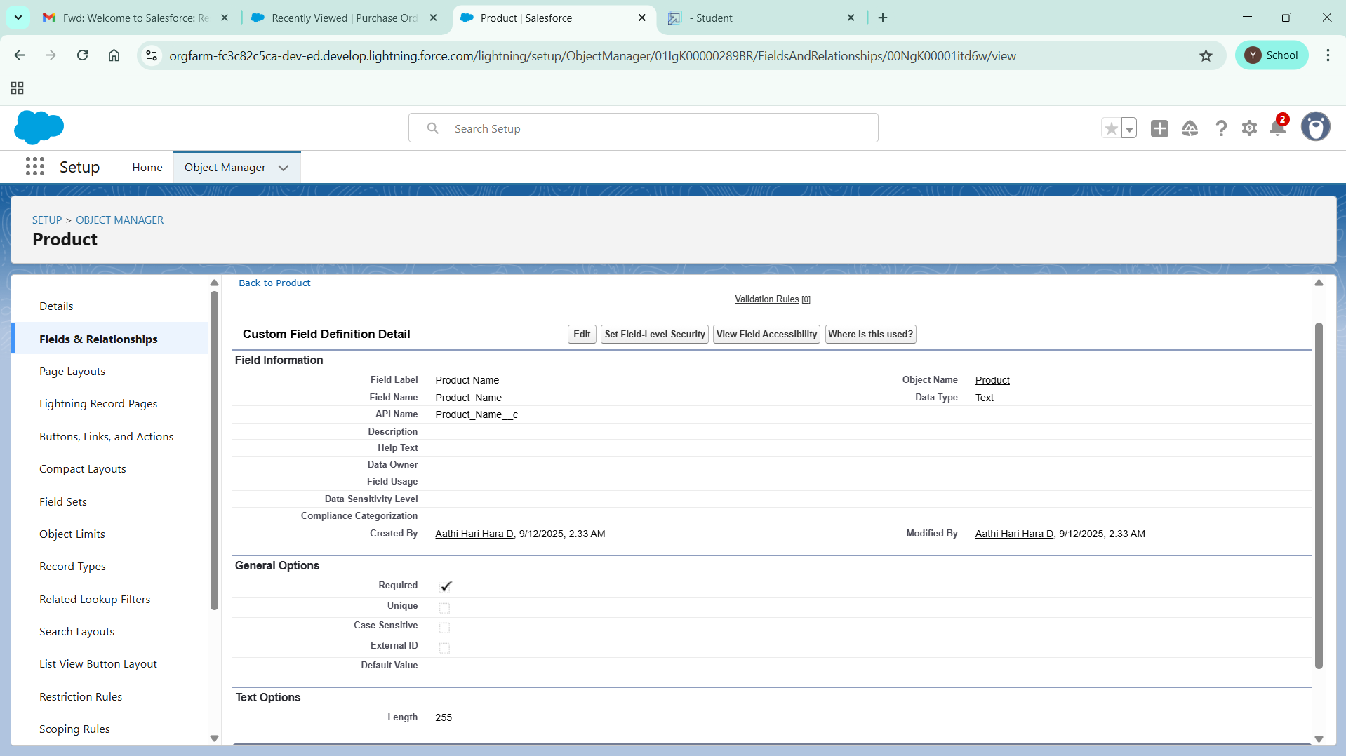

# **Creating a TextArea Field in Product Object**

### To create fields in an object:

1. Click the gear icon and select Setup. This launches Setup in a new tab.
2. Click the Object Manager tab next to Home.
3. Select Product custom object.
4. Select Fields & Relationships from the left navigation
5. Click on New
6. Select TextArea field, click Next
7. Enter Field Label as “Product Description” .
8. Click Next, Next, then Save & New.

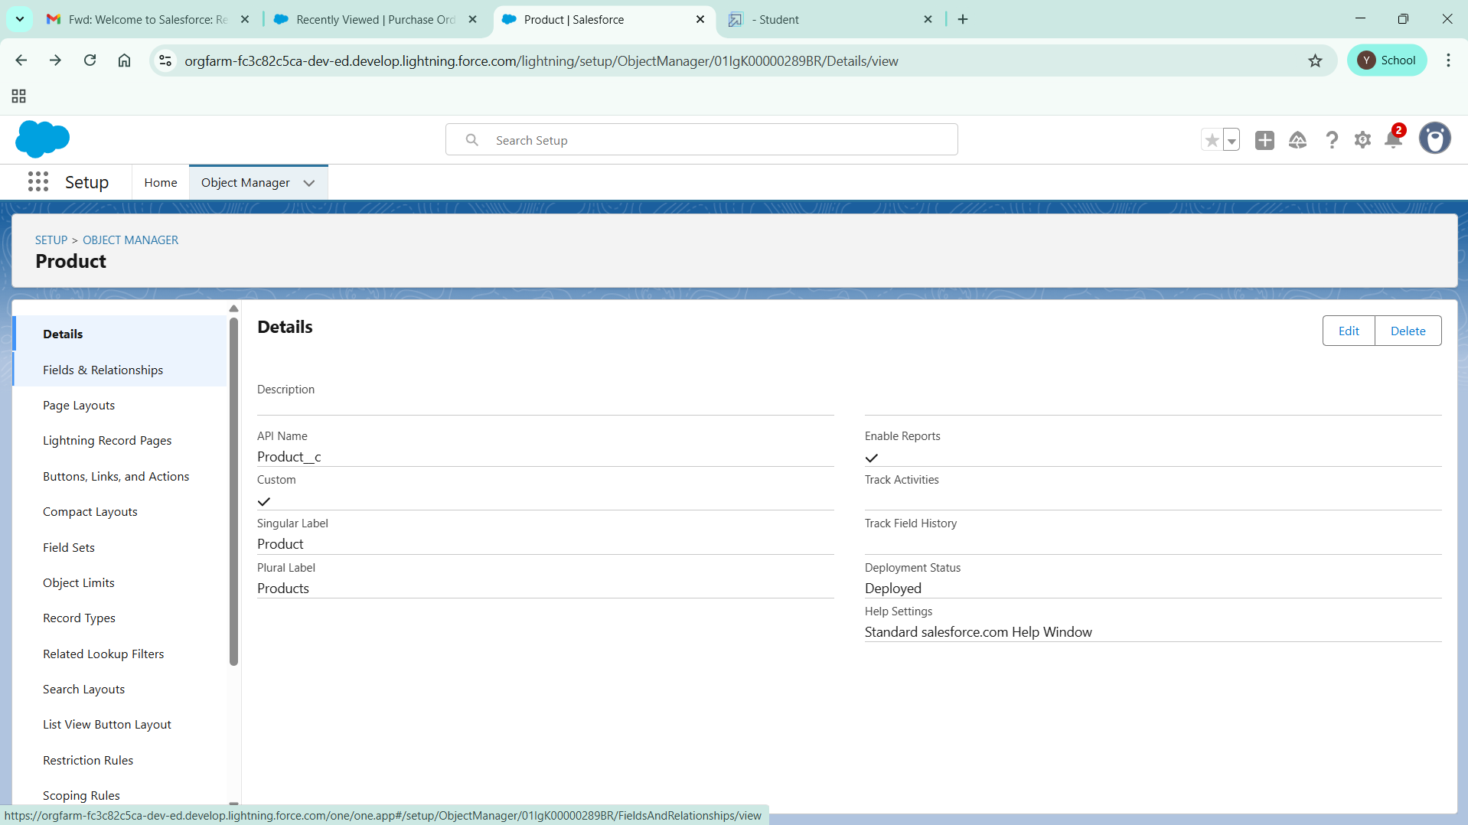

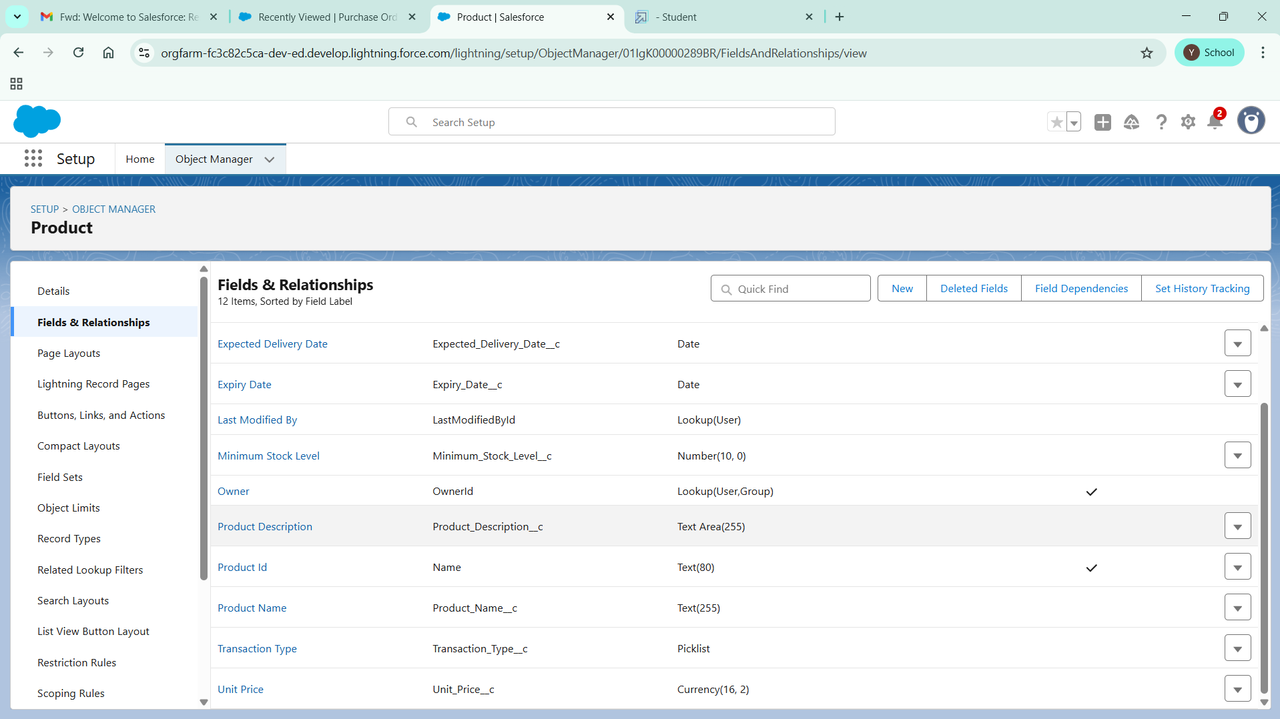

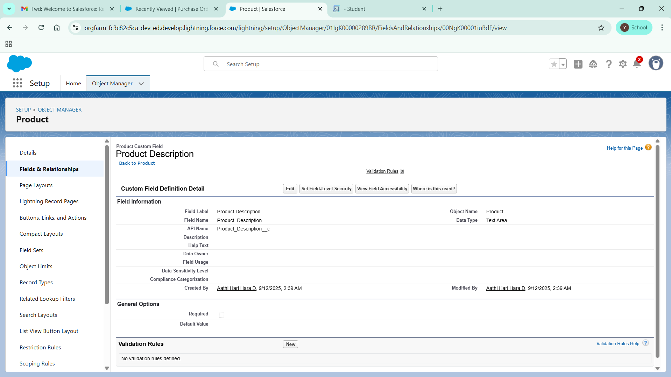

# Creating a Number Field in Product object

### To create fields in an object:

1. Go to setup >> click on Object Manager >> type object name(Product) in quick find box >> click on the Product custom object.
2. Now click on “Fields & Relationships”
3. Click on New.
4. Select Data type as “Number” and click Next.
5. Enter Field Label as “ Current Stock Level”.
6. Length - 18, Decimal Places - 0.
7. Click on Next, Next and Save.

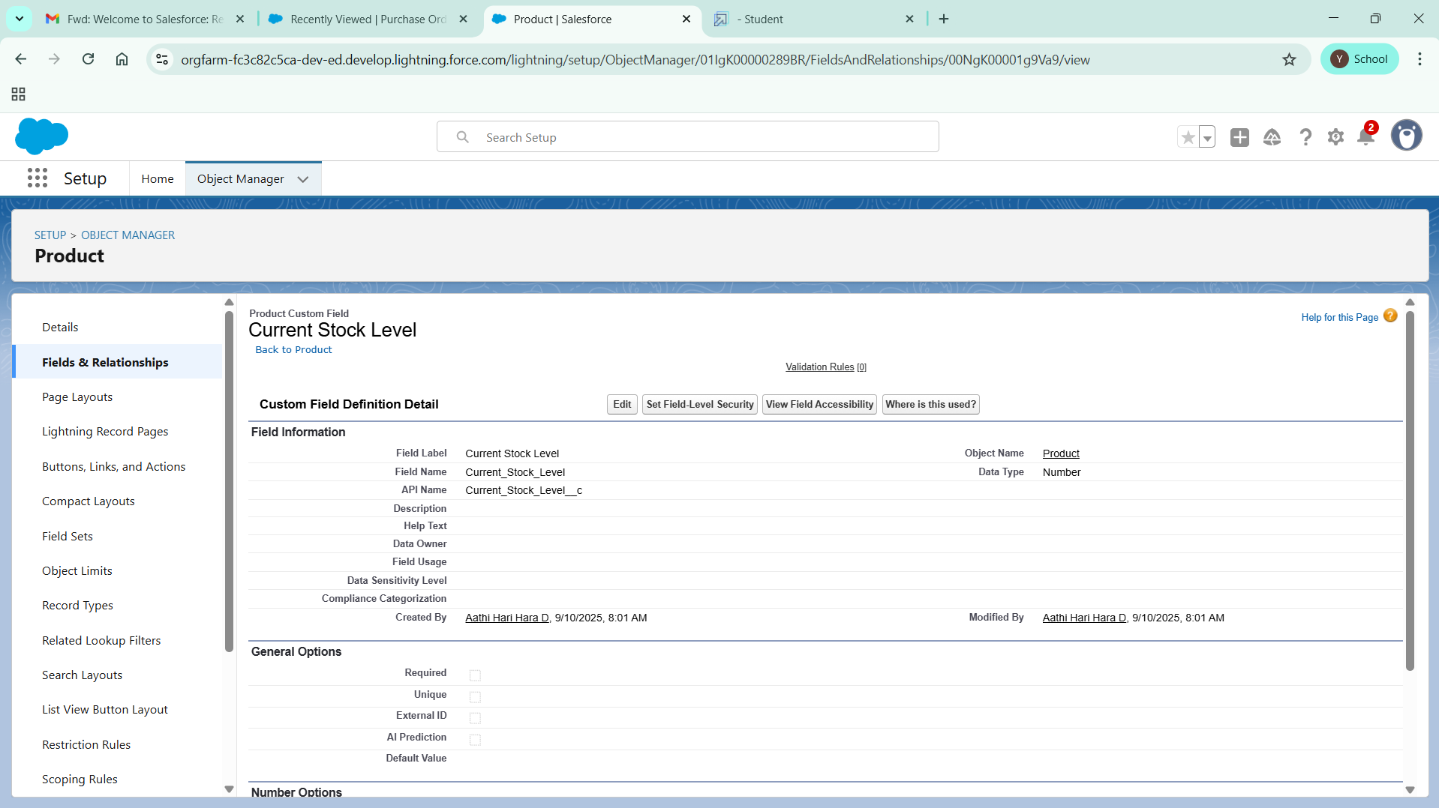

# Creating a Currency Field in Product object

### To create fields in an object:

1. Go to setup >> click on Object Manager >> type object name(Product) in quick find box >> click on the Product custom object.
2. Now click on “Fields & Relationships”
3. Click on New.
4. Select Data type as “Currency” and click Next.
5. Enter Field Label as “ Unit Price”.
6. Length - 16, Decimal Places - 2.
7. Select Required Field.
8. Click on Next, Next and Save.

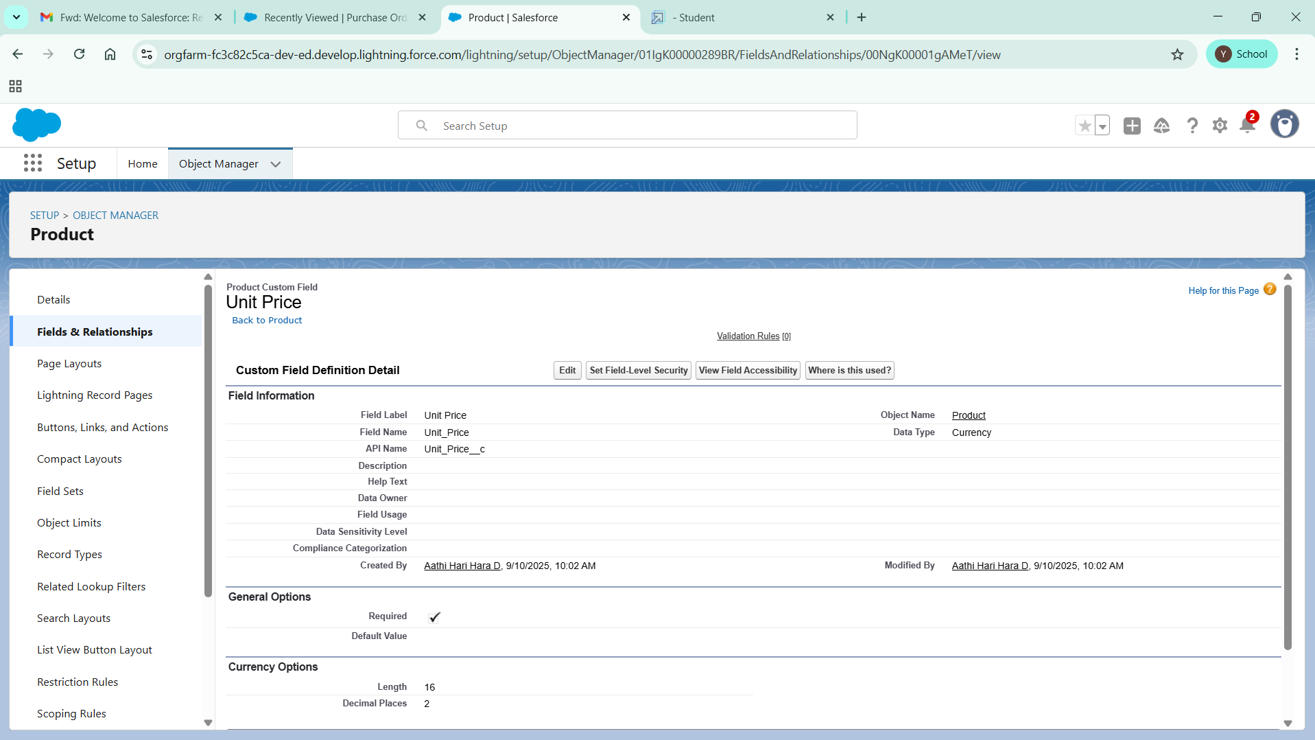

# Creating Lookup Relationship in Purchase Order Object

A Lookup relationship is a type of relationship in Salesforce that connects two objects together based on a field known as the Lookup field. It establishes a relationship between a child object and a parent object, allowing the child object to reference the parent object.

### To Create a relationship from Purchase Order to Supplier .

1. Go to the Setup page >> click on Object manager >> type object name(Purchase Order) in the quick find bar >> click on the Purchase Order object.
2. Click on Fields & Relationship
3. Click on New.
4. Select “Lookup relationship” as data type and click Next.
5. Select the related object “ Supplier”.
6. Click on Next.
7. Give Field Label as “Supplier ID” .
8. Select Required Field.
9. Click on Next , Next, Next , Save.

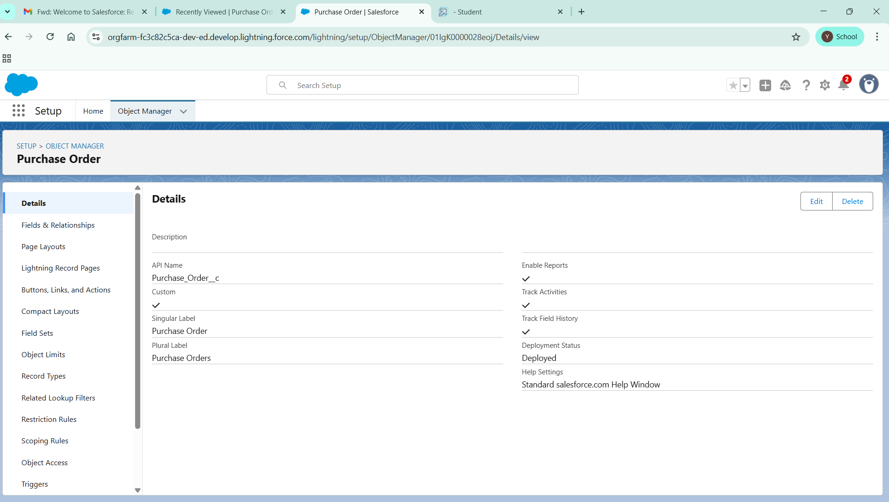

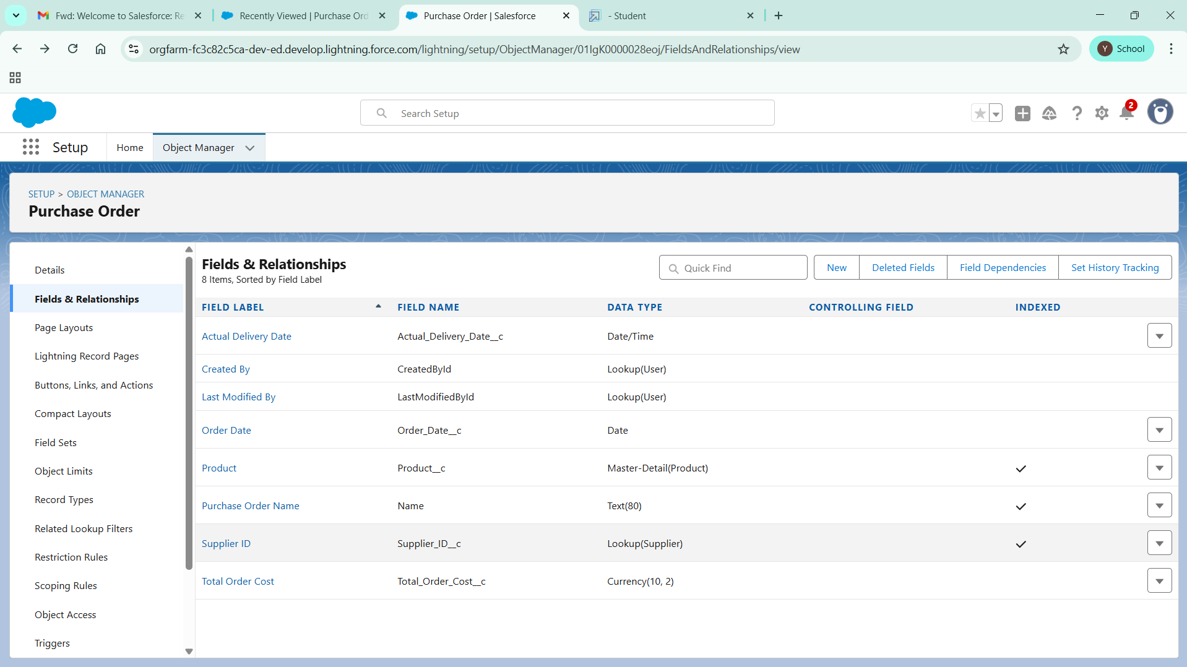

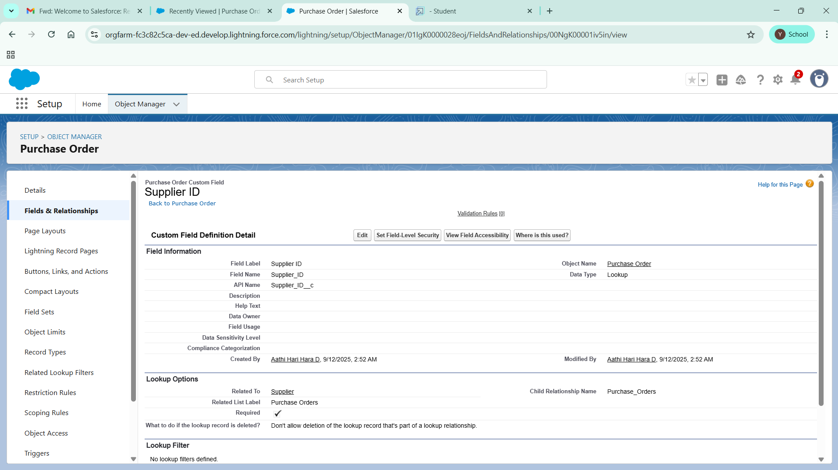

# Creating a Date Field in Purchase Order object

### To create fields in an object:

1. Go to setup >> click on Object Manager >> type object name(Purchase Order) in quick find box>> click on the Purchase Order object.
2. Now click on “Fields & Relationships”
3. Click on New.
4. Select Data type as “Date” and click Next.
5. Enter Field Label as “ Order Date”.
6. Click on Next, Next and Save.

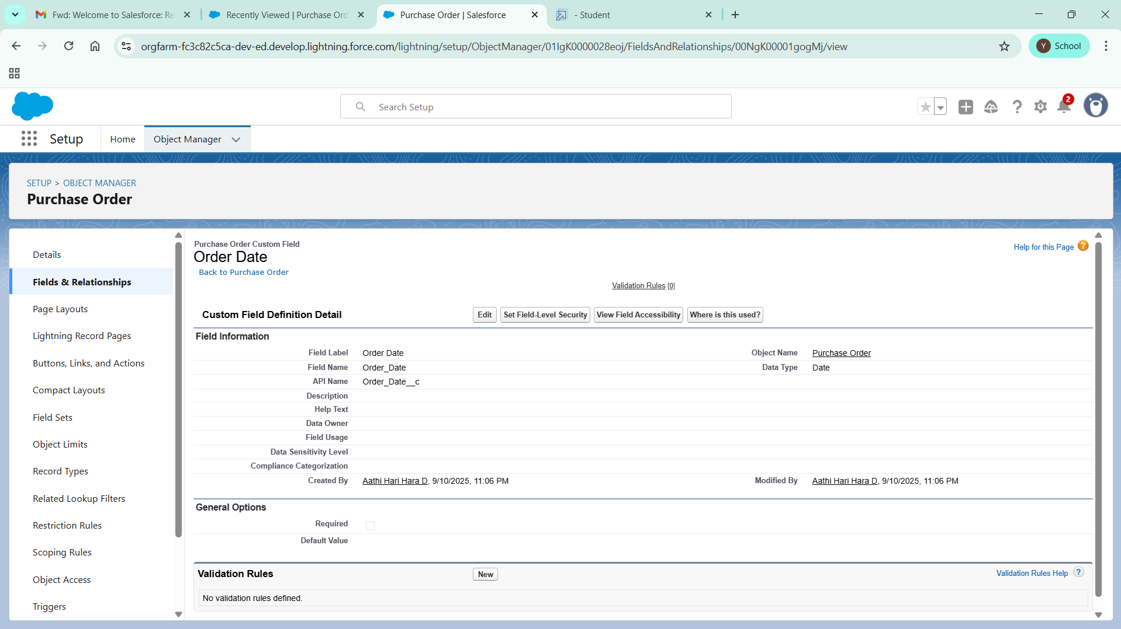

# Creating a Roll-Up Summary Field in Purchase Order object

### To create fields in an object:

1. Go to setup >> click on Object Manager >> type object name(Purchase Order) in quick find box>> click on the Purchase Order object.
2. Now click on “Fields & Relationships”
3. Click on New.
4. Select Data type as “Roll-Up Summary” and click Next.
5. Enter Field Label as “ Order Count”.
6. Choose the Summarized Object as “Order Items”.
7. For Select Roll-Up Type select “Count”.
8. Click on Next, Next and Save.

# Creating a Unit Price Formula Field in Order Item object

### To create fields in an object:

1. Go to setup >> click on Object Manager >> type object name(Order Item) in quick find box >> click on the Order Item object.
2. Now click on “Fields & Relationships”
3. Click on New.
4. Select Data type as “Formula” and click Next.
5. Enter field label Unit Price.
6. Select formula return type Currency, Click Next
7. Create and insert Advance formula:  Product_ID__r.Unit_Price__c
8. Click Next, Next, then Save.

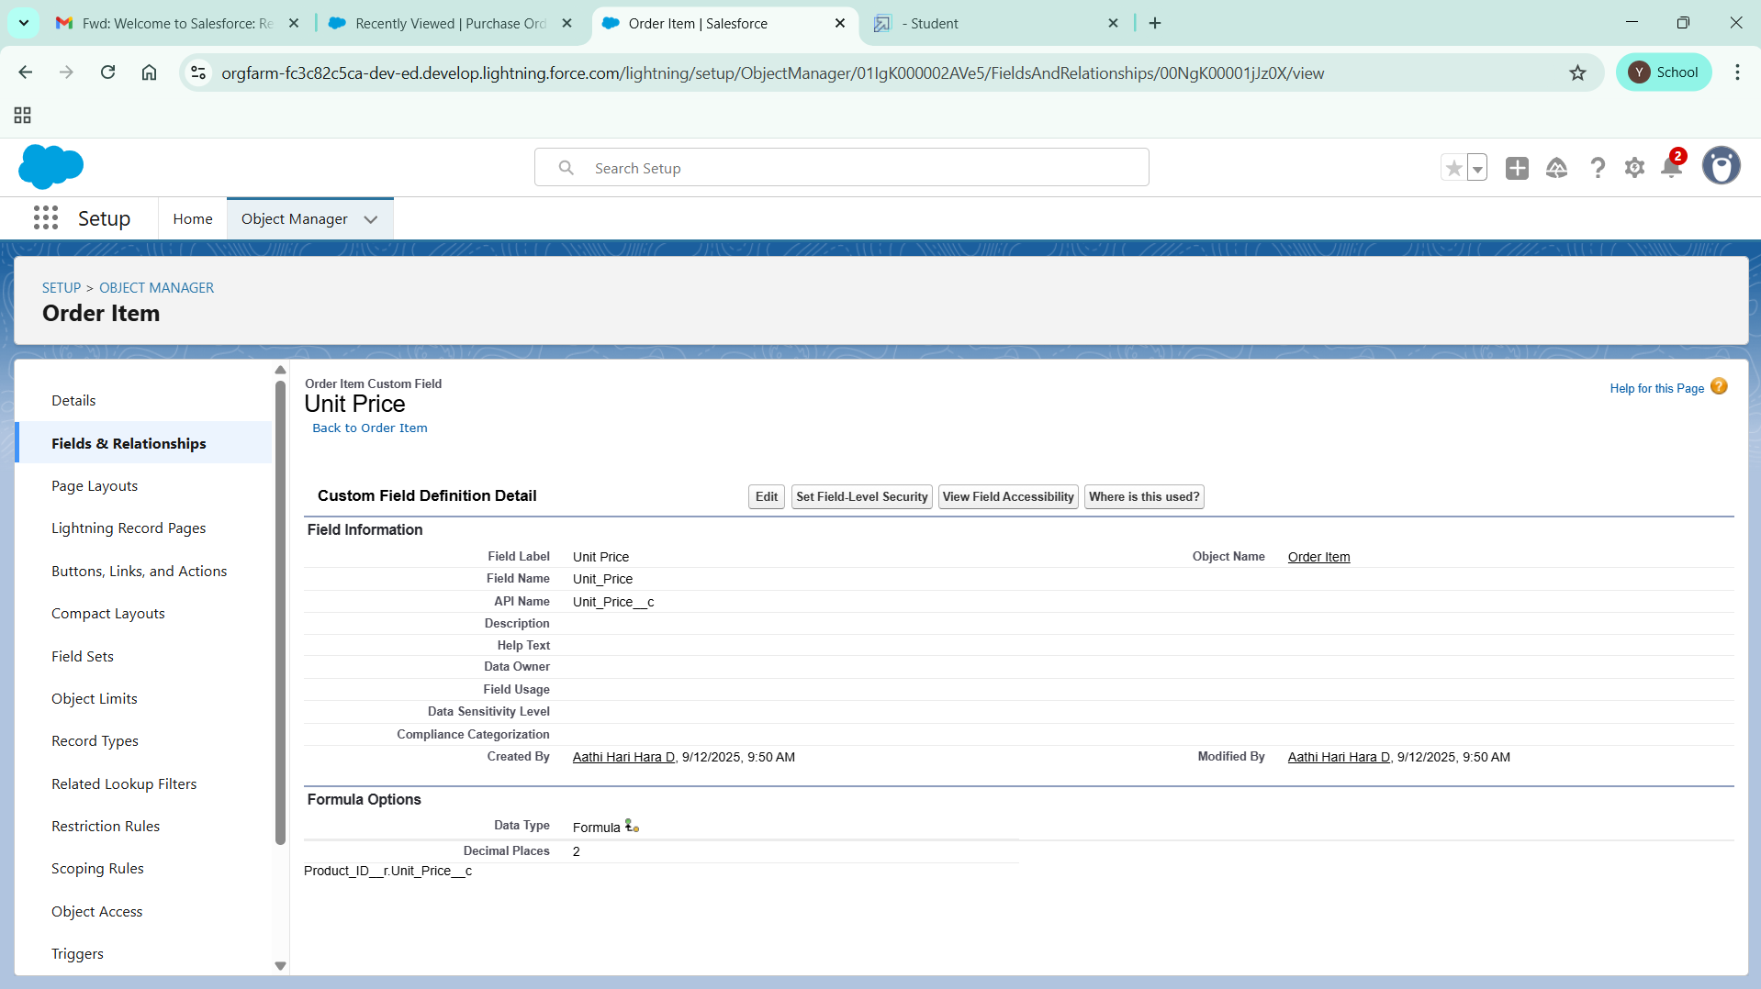

# Creating a Amount Formula Field in Order Item object

### To create fields in an object:

1. Go to setup >> click on Object Manager >> type object name(Order Item) in quick find box >> click on the Order Item object.
2. Now click on “Fields & Relationships”
3. Click on New.
4. Select Data type as “Formula” and click Next.
5. Enter field label Amount.
6. Select formula return type Currency, Click Next
7. Create and insert Advance formula:  Quantity_Received__c  *  Unit_Price__c
8. Click Next, Next, then Save.

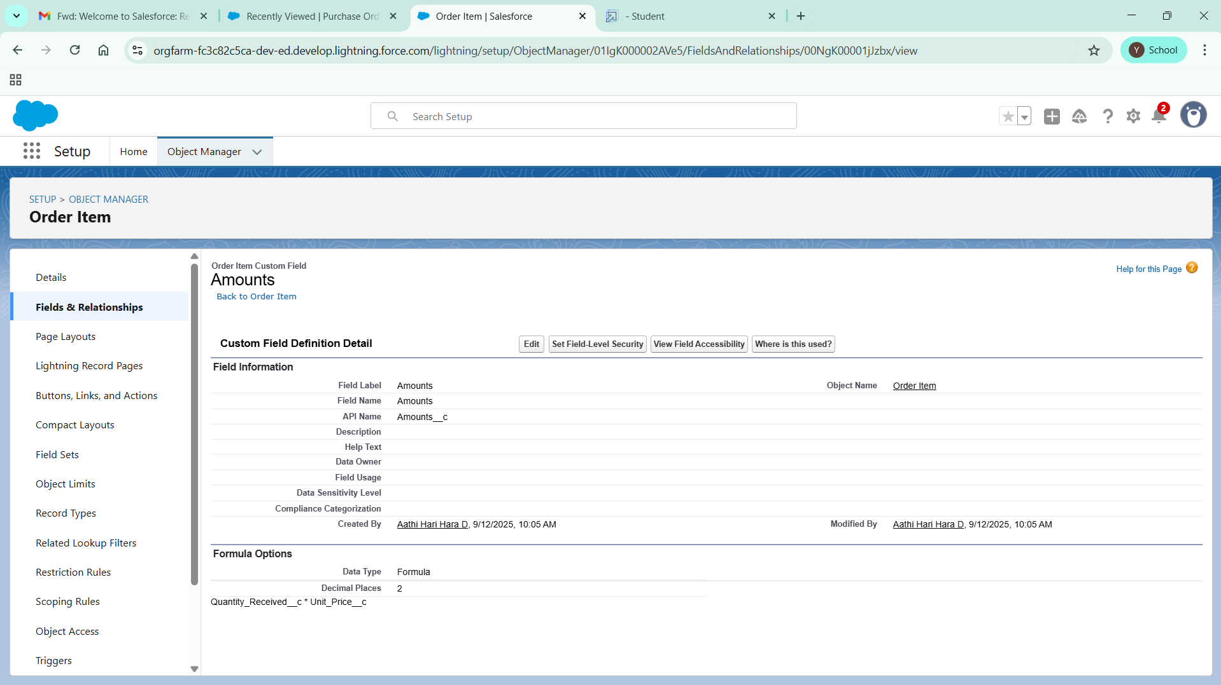

# Creating a Picklist Field in Inventory Transaction Object

### To create fields in an object:

1. Go to setup >> click on Object Manager >> type object name(Inventory Transaction) in quick find box>> click on the Inventory Transaction Object.
2. Now click on “Fields & Relationships” .
3. Click on New.
4. Select Data type as “Picklist” and click Next.
5. Enter Field Label as “Transaction Type”.
6. In values select “Enter values, with each value separated by a new line" and enter values as shown below.

Receipt

Issue

Adjustment

1. Click on Next, Next and Save.

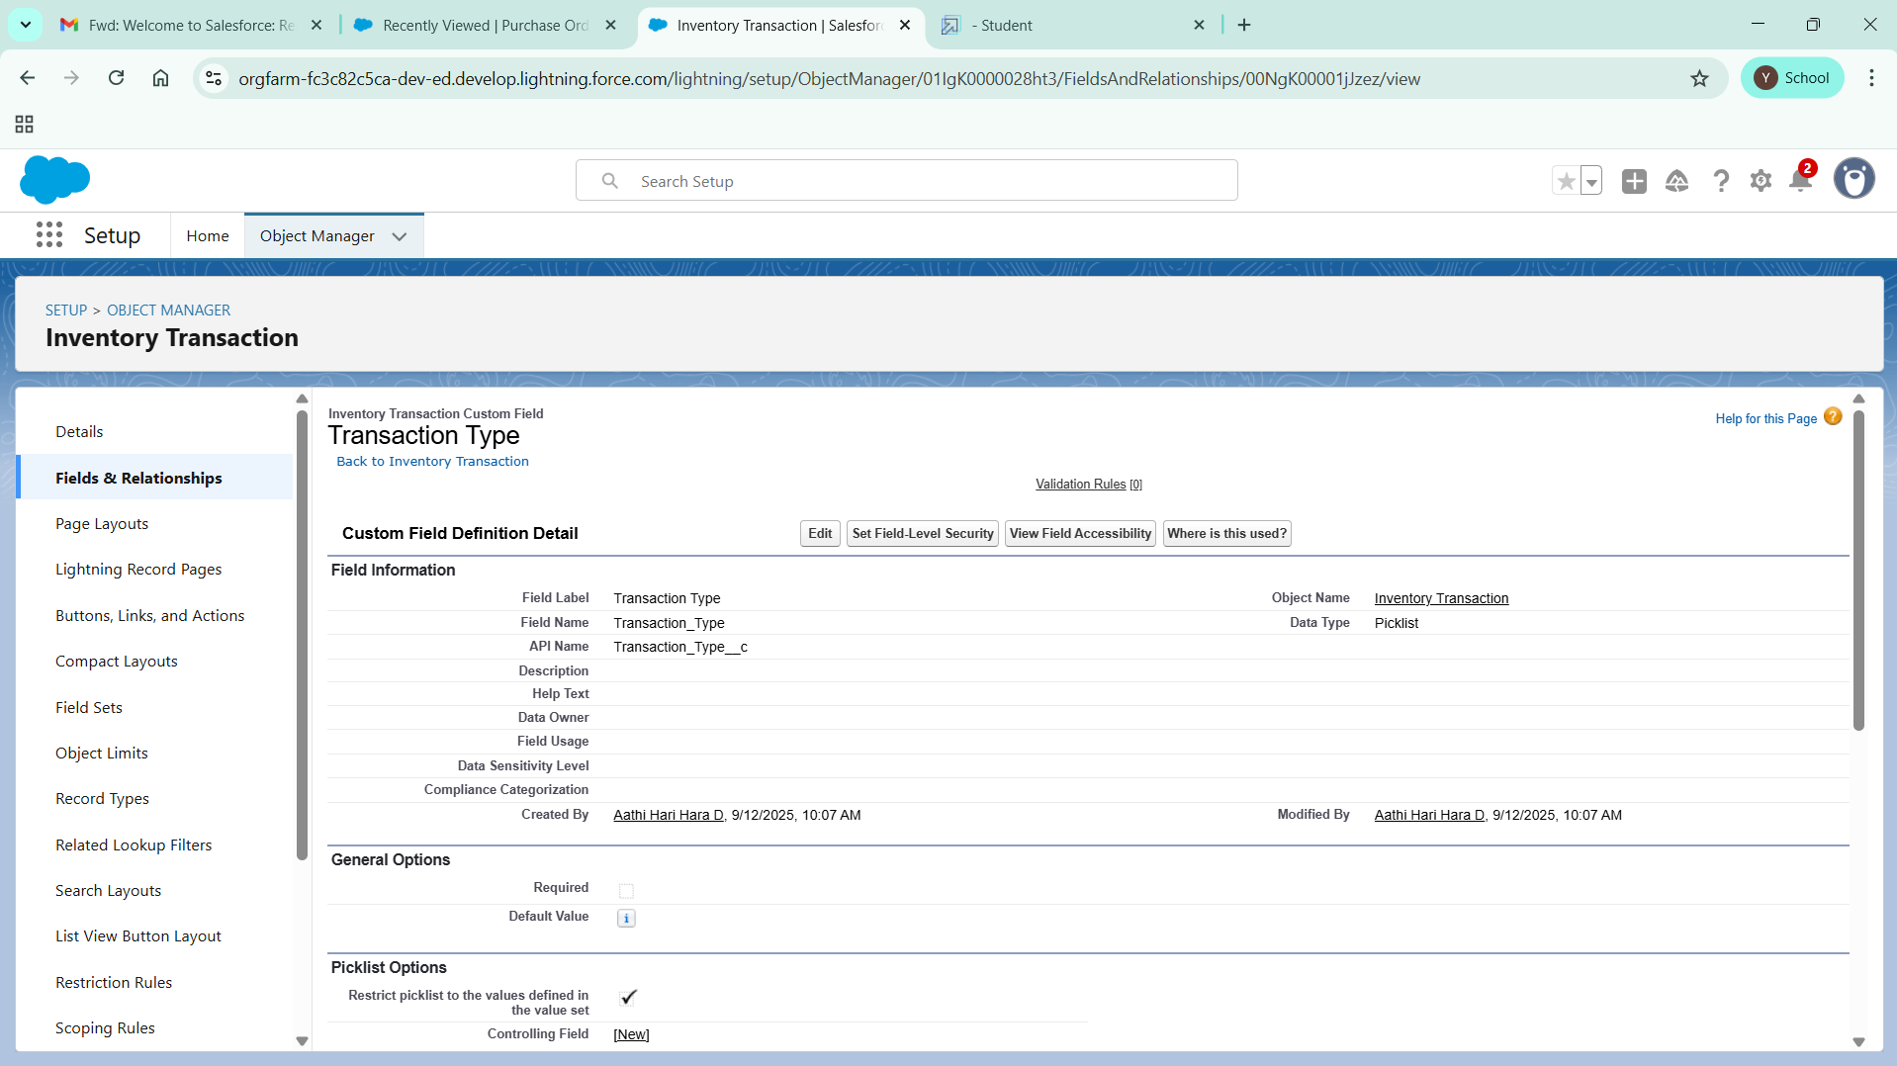

# Creating a Total Order Cost Formula Field in Inventory Transaction object

### To create fields in an object:

1. Go to setup >> click on Object Manager >> type object name(Inventory Transaction) in quick find box >> click on the Order Item object.
2. Now click on “Fields & Relationships”
3. Click on New.
4. Select Data type as “Formula” and click Next.
5. Enter field label Total Order Cost.
6. Select formula return type Currency, Click Next
7. Create and insert Advance formula: Purchase_Order_ID__r.Total_Order_Cost__c
8. Click Next, Next, then Save.

# Creating a Phone Field in Supplier object

### To create fields in an object:

1. Go to setup >> click on Object Manager >> type object name(Supplier) in quick find box>> click on the Supplier object.
2. Now click on “Fields & Relationships”
3. Click on New.
4. Select Data type as “Phone” and click Next.
5. Enter the Field Label as “ Phone Number”.
6. Select Required Field.
7. Click on Next, Next and Save.

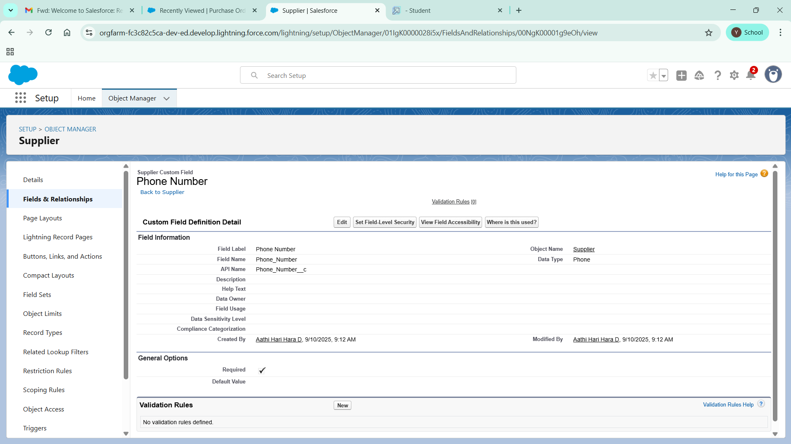

# Creating a Email Field in Supplier object

### To create fields in an object:

1. Go to setup >> click on Object Manager >> type object name(Supplier) in quick find box>> click on the Supplier object.
2. Now click on “Fields & Relationships”
3. Click on New.
4. Select Data type as “Email” and click Next.
5. Enter the Field Label as “ Email”.
6. Click on Next, Next and Save.

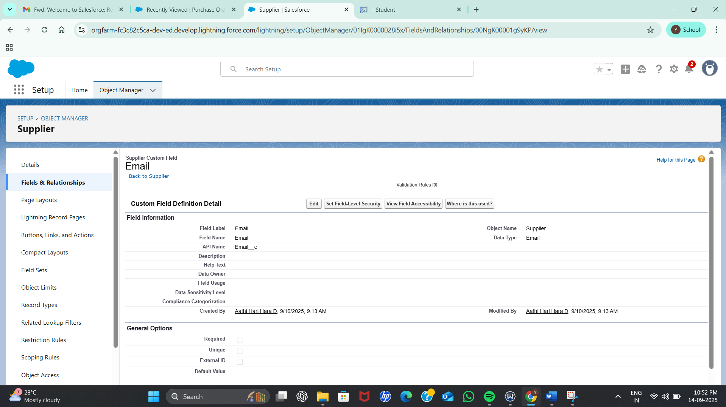

# To edit a Page Layout in Product Object

1. Go to setup >> click on Object Manager >> type object name(Product) in quick find box >> click on the Product object >> Page Layouts .
2. Click on the Product Layout.
3. Drag and Arrange the field as shown below.

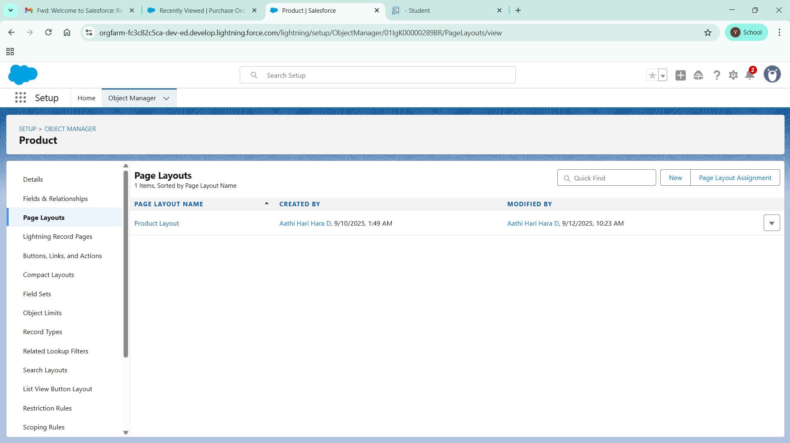

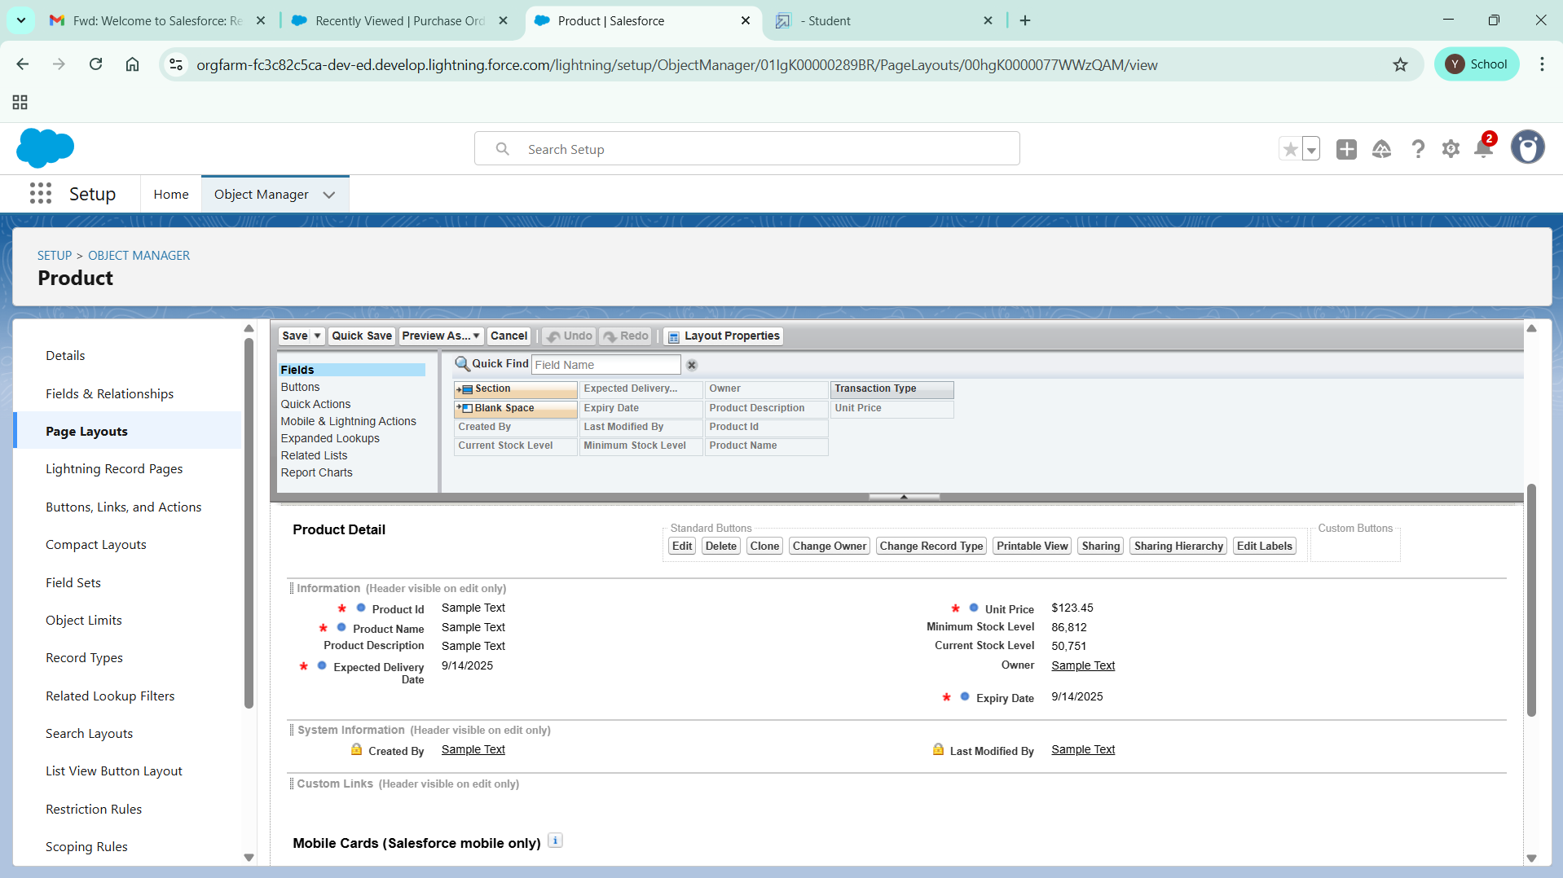

# To edit a Page Layout in Purchase Order Object

1. Go to setup >> click on Object Manager >> type object name(Purchase Order) in quick find box >> click on the Purchase Order object >> Page Layouts.
2. Click on the Purchase Order Layout
3. Drag and Arrange the field as shown below

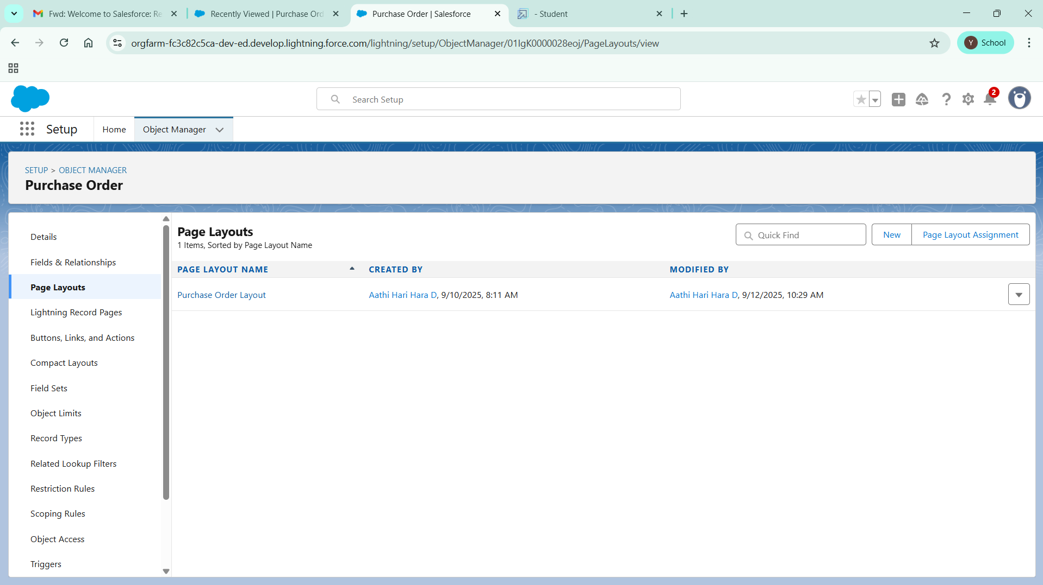

1. Click on field Order Date >> click on settings >> select Required and save it.
2. Click on field Total Order Cost >> click on settings>>select Read Only and save it.
3. Click Save.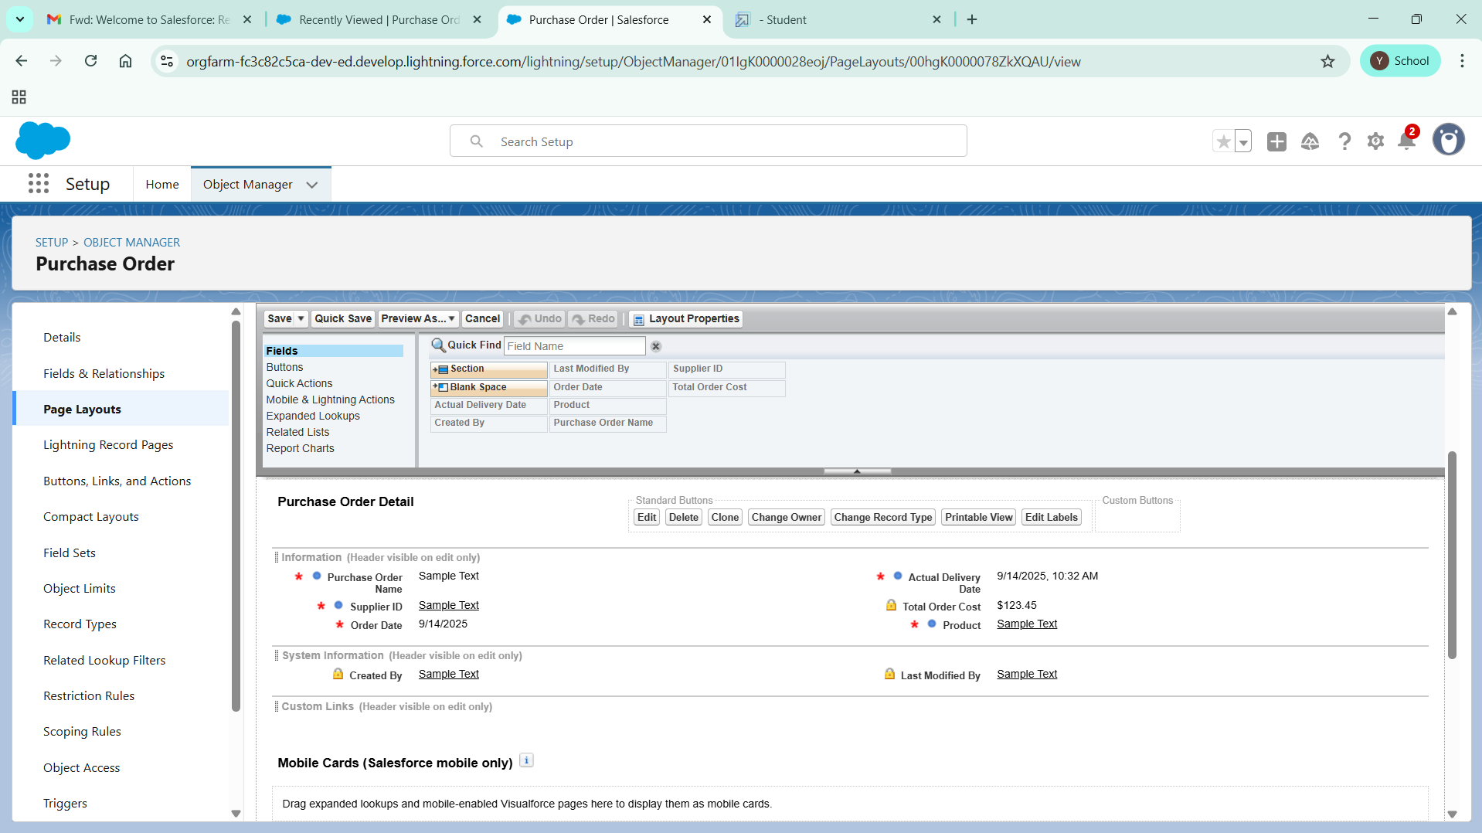

# To edit a Page Layout in Order Item Object

1. Go to setup >> click on Object Manager >> type object name(Order Item) in quick find box >> click on the Order Item object >> Page Layouts.
2. Click on the Order Item Layout
3. Drag and Arrange the field as shown below

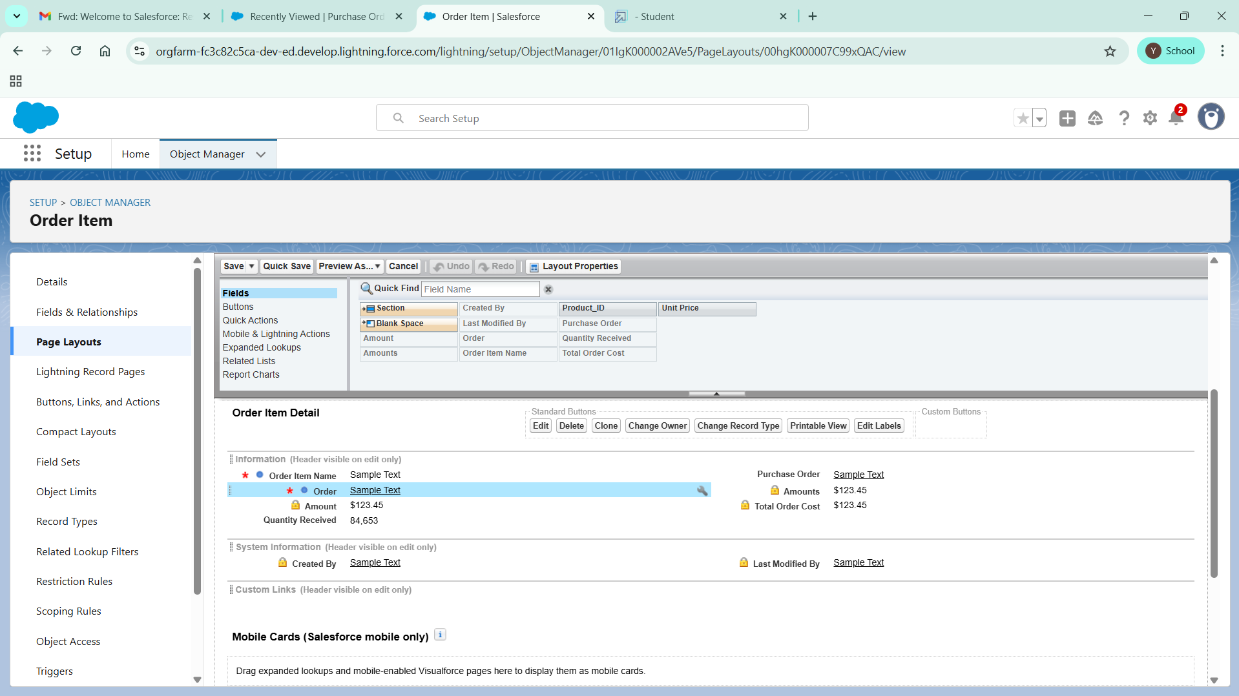

1. Click Save.

# To edit a Page Layout in Inventory Transaction Object

1. Go to setup >> click on Object Manager >> type object name(Inventory Transaction) in quick find box >> click on the Inventory Transaction object >> Page Layouts.
2. Click on the Inventory Transaction Layout
3. Drag and Arrange the field as shown below

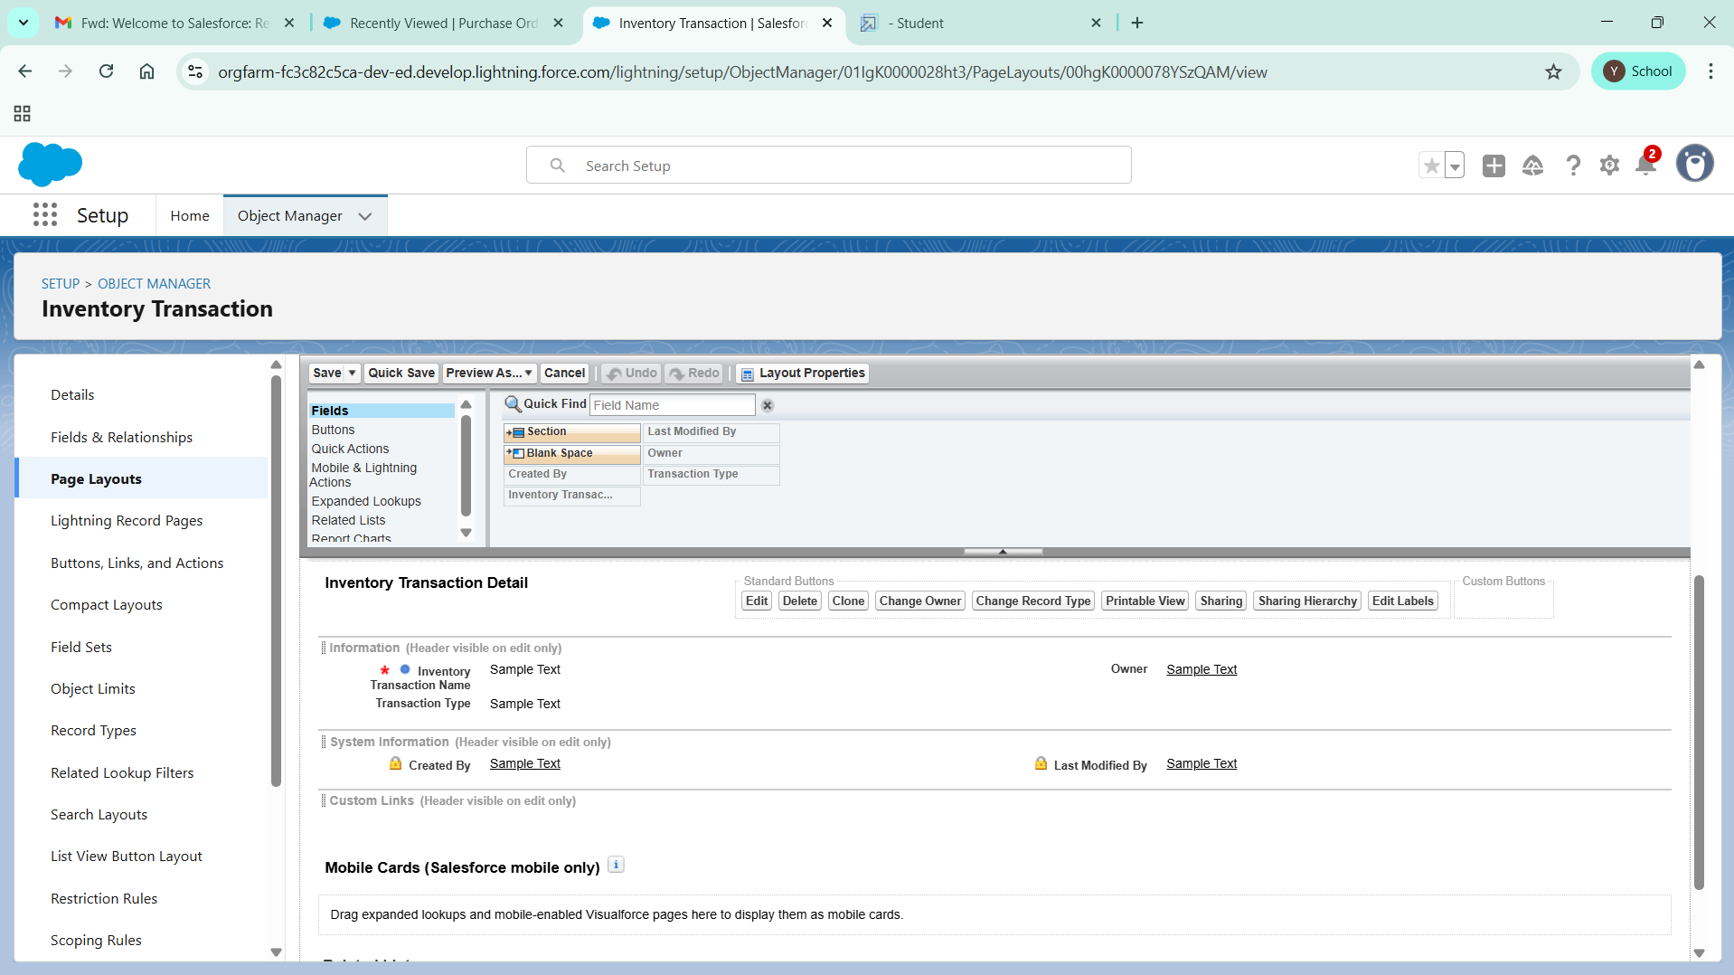

1. Click Save.

# To edit a Page Layout in Supplier Object

1. Go to setup >> click on Object Manager >> type object name(Supplier) in quick find box >> click on the Supplier object >> Page Layouts.
2. Click on the Supplier Layout
3. Drag and Arrange the field as shown below

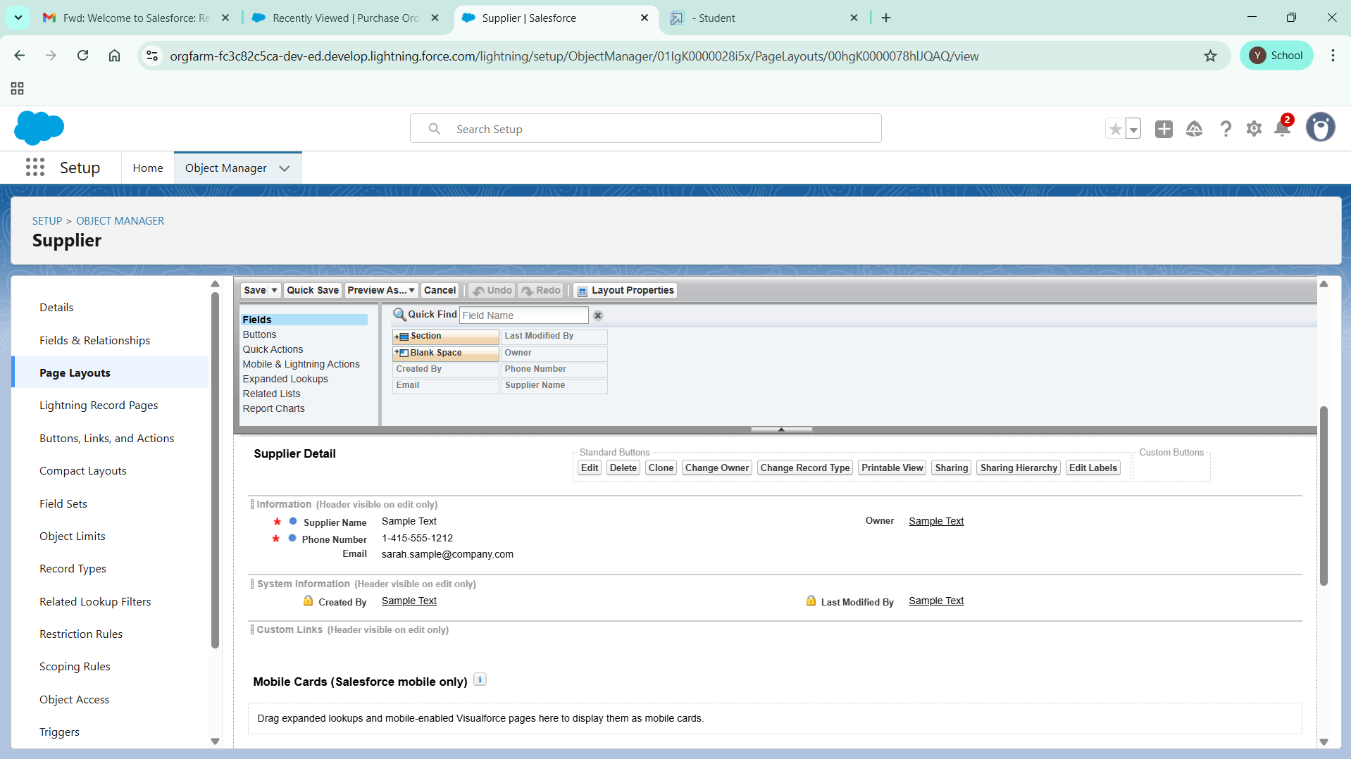

1. Click Save.

# To create a Compact Layout to a Product Object

1. Go to setup >> click on Object Manager >> type object name(Product) in quick find box >> click on the Product object
2. Click on Compact Layouts in the sidebar .
3. Click on New.
4. Enter the Label as “Product Compact Layout”.
5. Select the Compact Layout Fields : Select Product name, Unit Price, Current Stock Level.
6. Click Save.
7. Click Compact Layout Assignment.
8. Click Edit Assignment.
9. Choose "Product Compact Layout" from the dropdown.
10. Click Save.

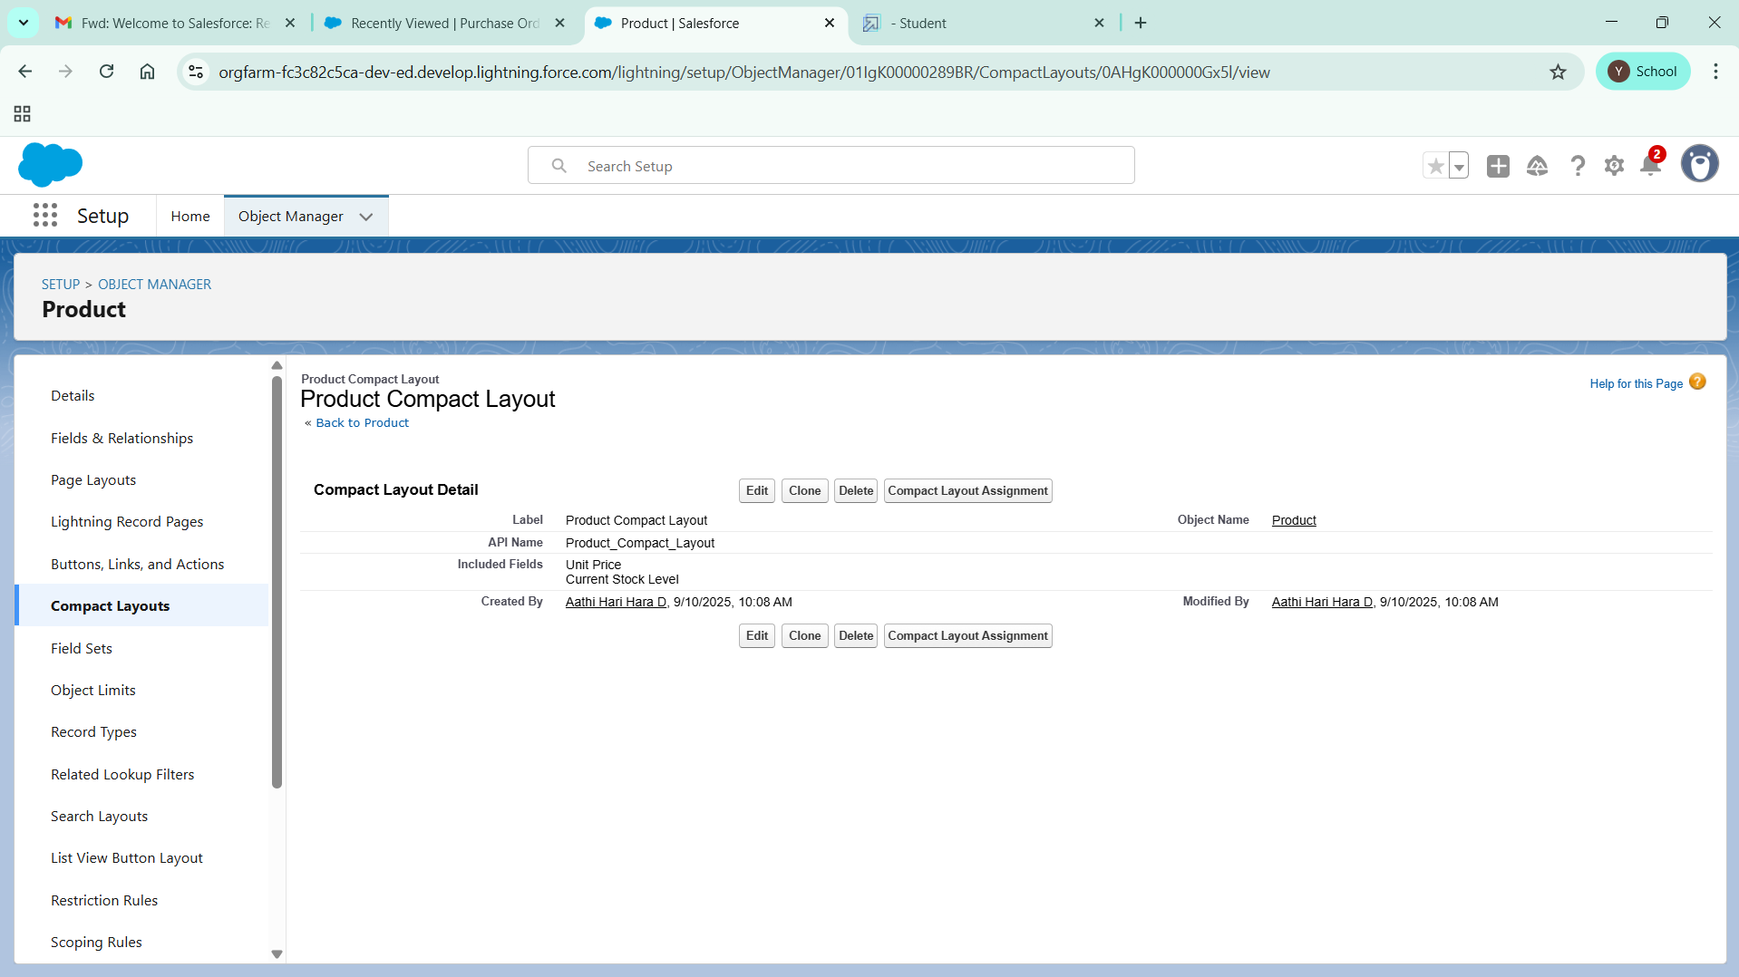

# To create a Compact Layout to a Purchase Order Object

1. Go to setup >> click on Object Manager >> type object name(Purchase Order) in quick find box >> click on the Purchase Order object
2. Click on Compact Layouts in the sidebar .
3. Click on New.
4. Enter the Label as “Purchase Order Compact Layout”.
5. Select the Compact Layout Fields : Select Purchase Order ID, Order Date, Total Order Cost, Supplier ID.
6. Click Save.
7. Click Compact Layout Assignment.
8. Click Edit Assignment.
9. Choose "Purchase Order Compact Layout" from the dropdown.
10. Click Save.

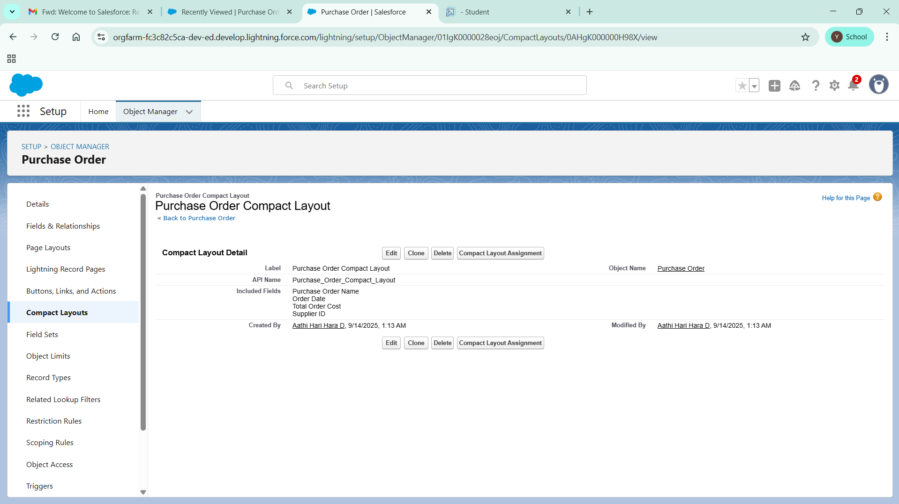

# To create an Expected Delivery Date Validation rule to a Employee Object

1. Go to setup >> click on Object Manager >> type object name(Purchase Order) in quick find box>> click on the Purchase Order object
2. Click on the validation rule >> click on New.
3. Enter the Rule name as “Expected Delivery Date Validation”.
4. Select Active
5. Insert the Error Condition Formula as :  
   (Expected_Delivery_Date__c   -  Order_Date__c )> 7

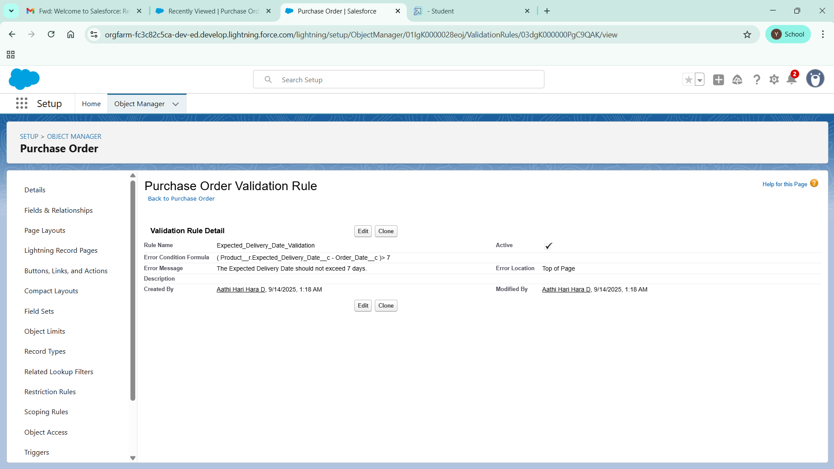

1. Enter the Error Message as “The Expected  Delivery Date should not exceed 7 days.”.
2. Select the Error location as Top of Page
3. Click Save.

# To create an Inventory Manager Profile

1. Go to setup >> type profiles in quick find box >> click on profiles >> clone the desired profile (Standard User) >> enter profile name (Inventory Manager) >> Save.

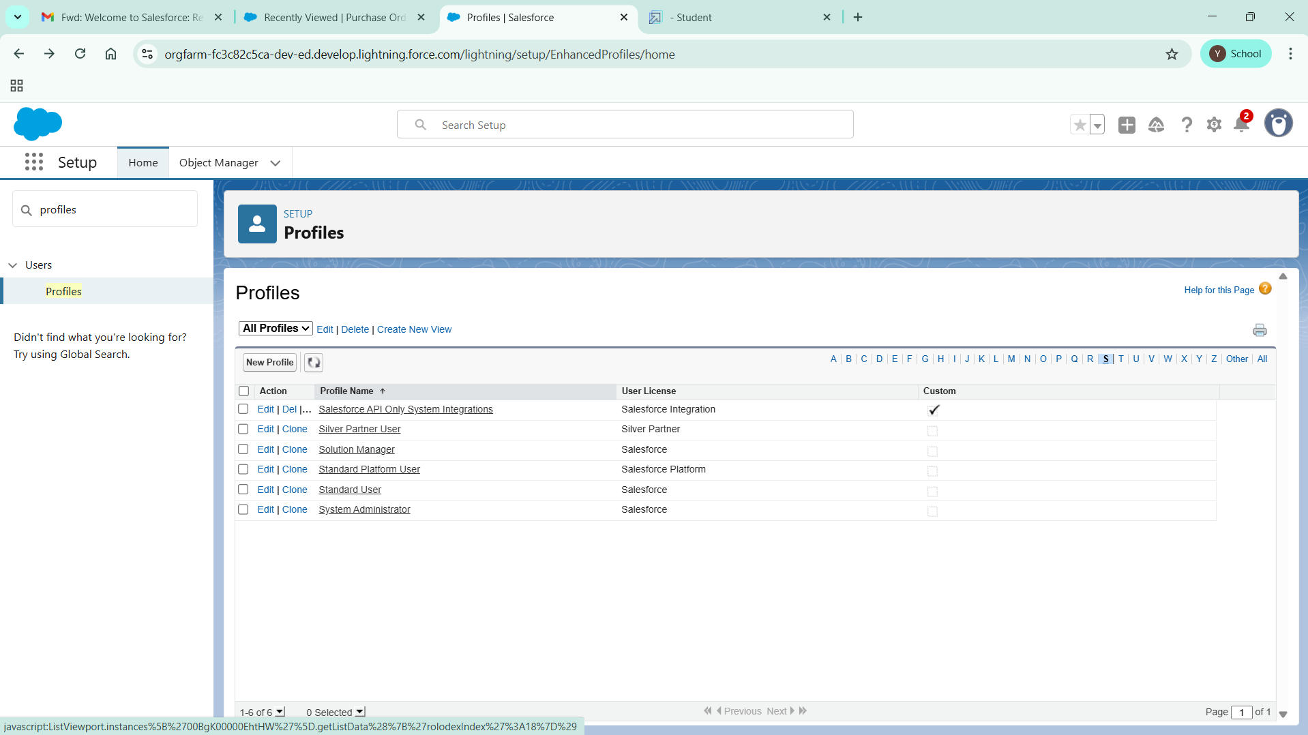

1. While still on the profile page, then click Edit.
2. Select the Custom App settings as default for the Medical Inventory Management.

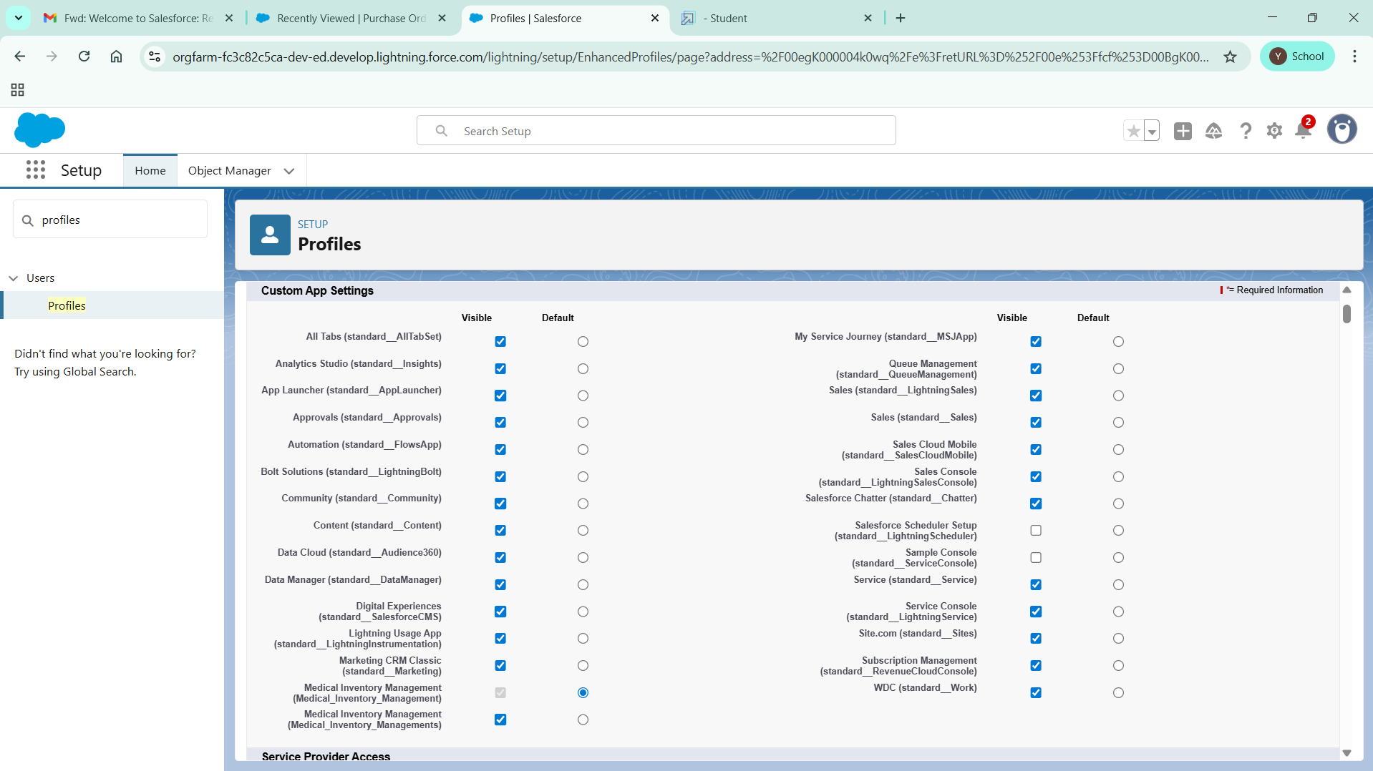

1. Scroll down to Custom Object Permissions and Give access permissions as mentioned in the below diagram.
2. Change the password policies as mentioned :
3. User passwords expire in should be “ never expires ”.
4. Minimum password length should be “ 8 ”, and click save.

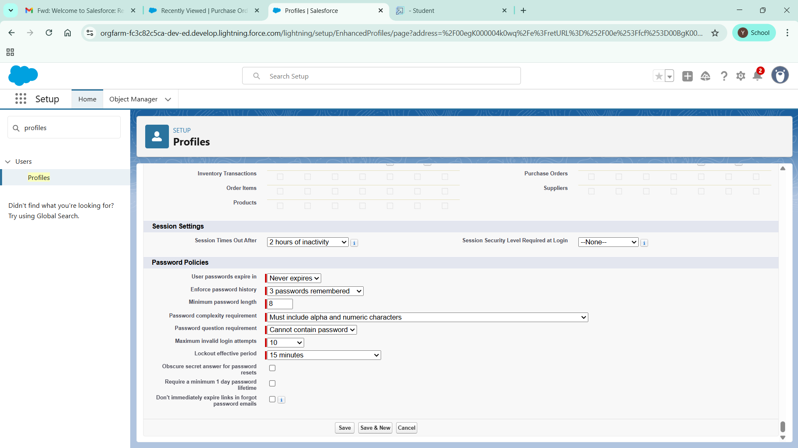

# Create a Purchasing Manager Role.

1. Go to quick find  >>  Search for Roles >> click on Set Up Roles.

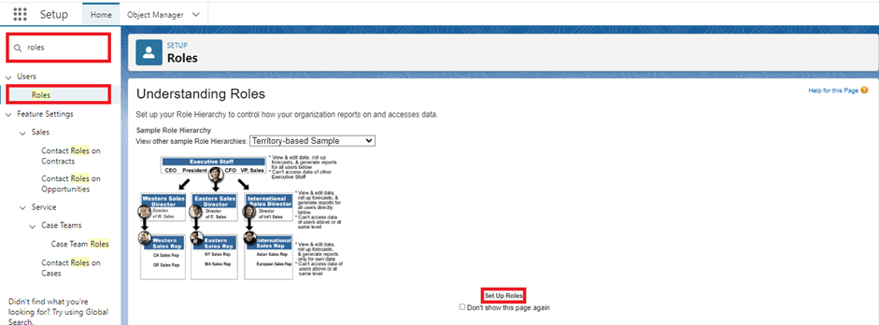

1. Click on Expand All and click on add role under SVP, Sales & Marketing  role.
2. Give Label as “Purchasing Manager” and Role name gets auto populated. Then click on Save.

# Create a Purchasing Manager Role.

1. Go to quick find  >>  Search for Roles >> click on Set Up Roles.

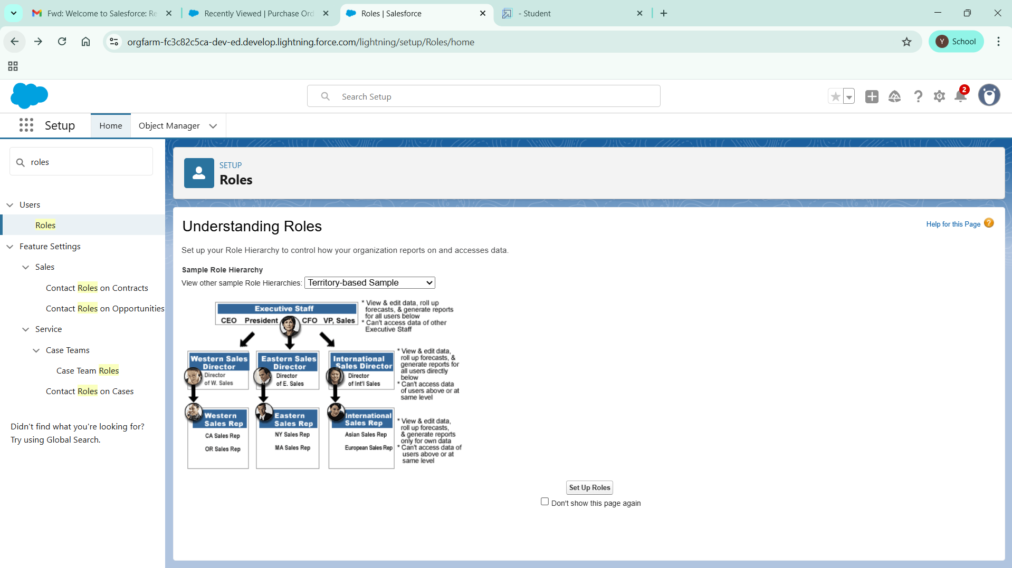

1. Click on Expand All and click on add role under SVP, Sales & Marketing  role.
2. Give Label as “Inventory Manager” and the Role name gets auto populated. Then click on Save.

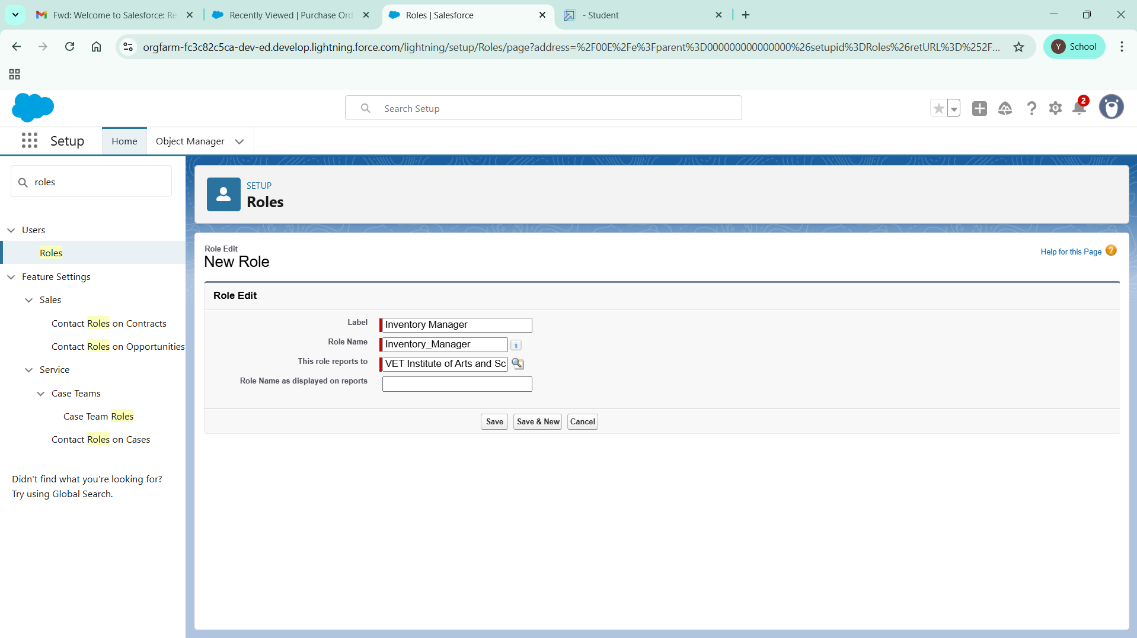

# Create a Permission Set.

1. Go to setup >> type Permission in quick find box >> Select Permission Set >> click on New.

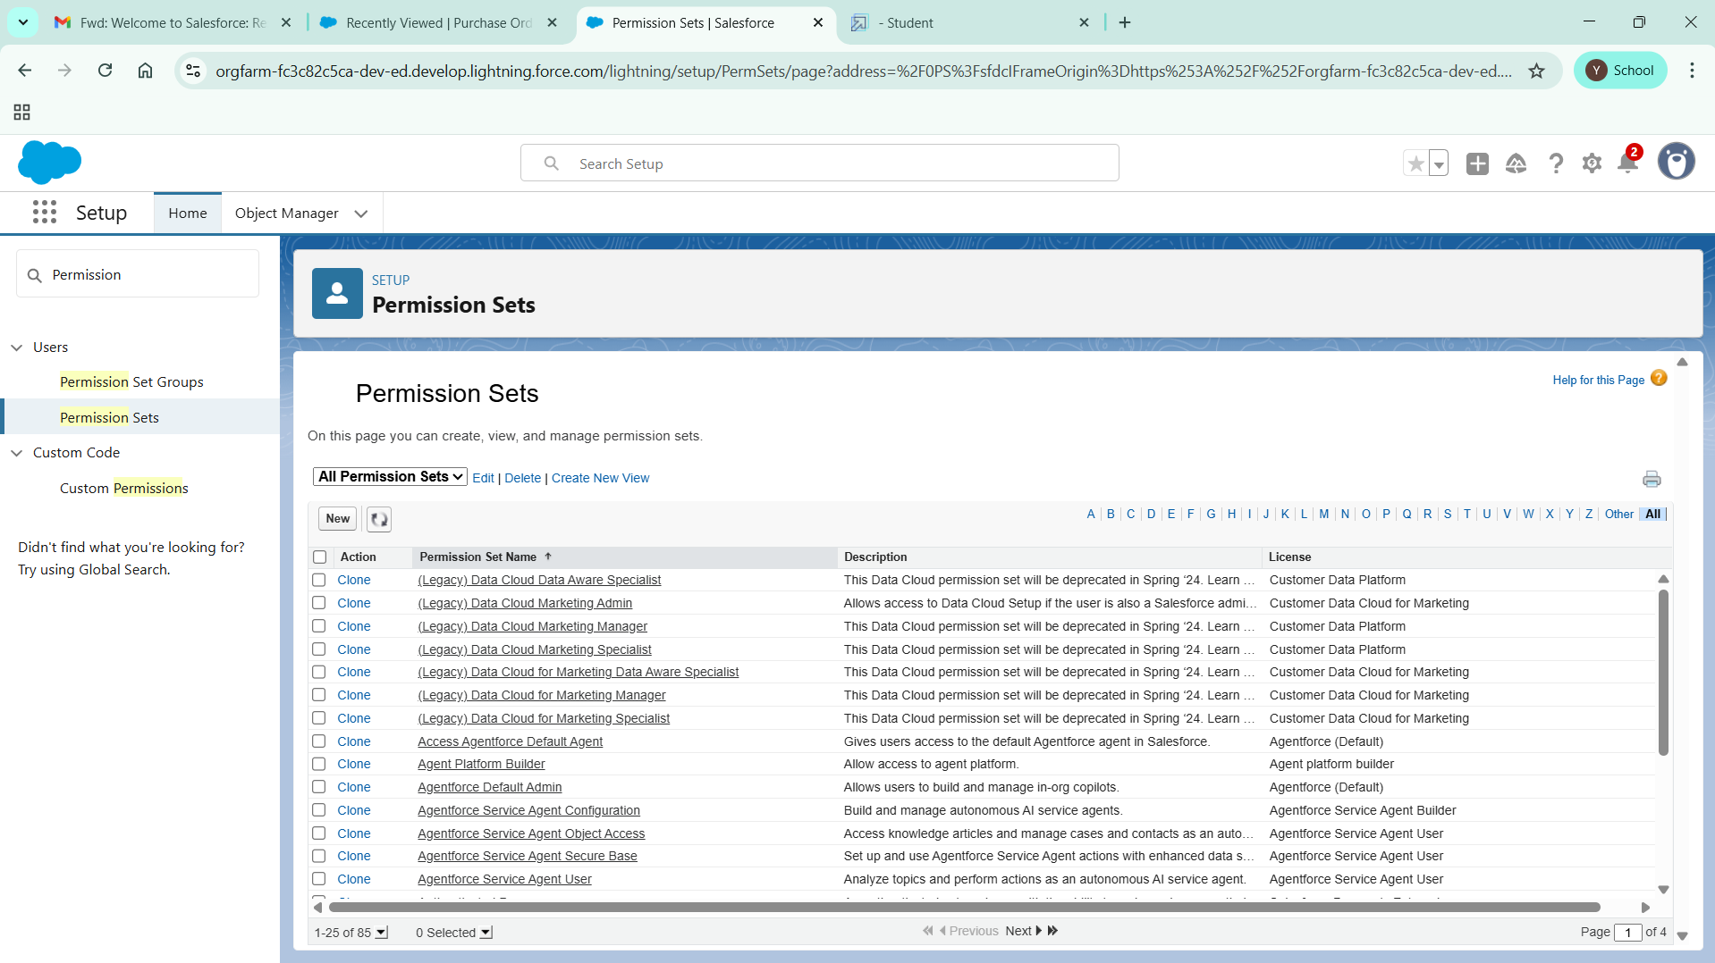

1. Enter Label as Purchase Manager Create Access >> Click on Save.

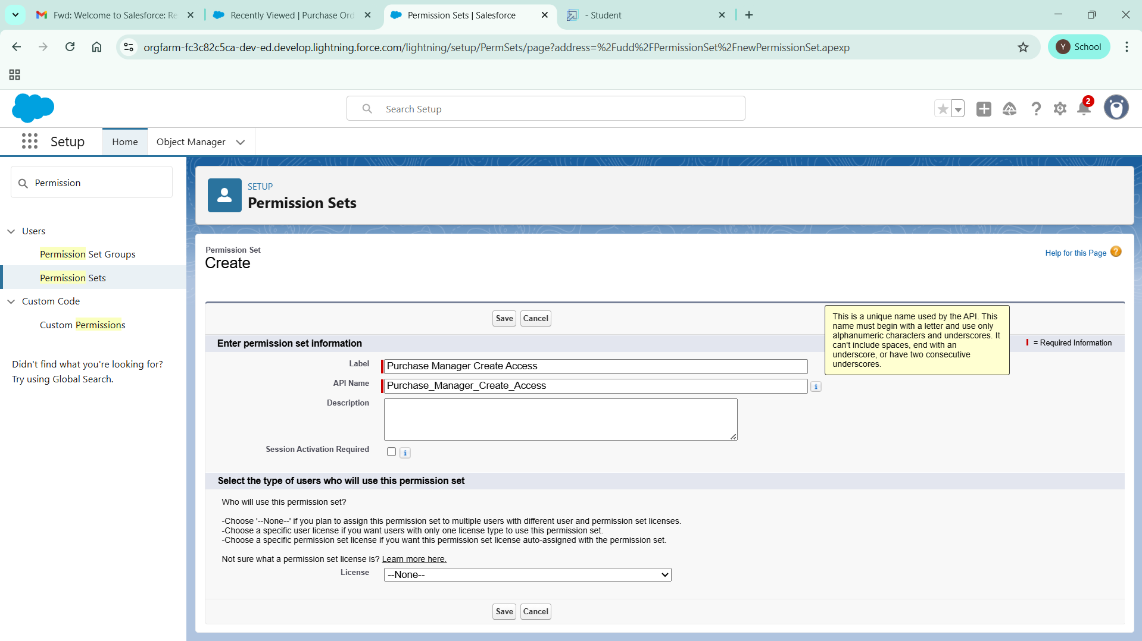

1. From Object Settings  >> Select Order Item >> Enable for both Tab Available and Visible  >> Enable Read and Create in Object Permissions >> Click on Save.
2. Navigate to the Permission Set detail page >> Click Manage Assignments >> Click Add Assignments >> Select the user John Purchase to assign the permission set to and click Next.
3. Select No Expiration date >> Click on Assign.

**Create a Trigger to Calculate total amount on Order Item.**

Step 1 : Login to Salesforce:

Log in to your Salesforce account with administrative privileges.

Step 2:

i)Navigate to Setup: Once logged in, click on the gear icon ?? (Setup) located at the top-right corner of the page. This will open the Setup menu.

ii)Click on Developer Console: Click on the "Developer Console" option from the Setup menu.   This will open the Developer Console in a new browser tab or window.

Step 3:

i) In the Developer Console window, go to the top menu and click on "File".

ii)Select New: From the dropdown menu under "File", select "New".

iii)Choose Apex Trigger: This will open a new Apex Trigger editor tab.

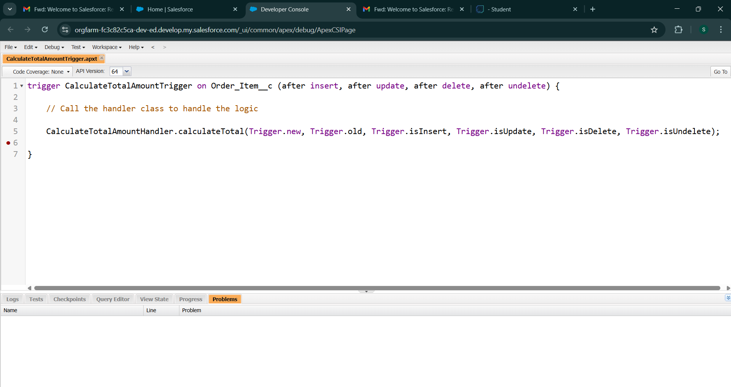

Step 4:

i) In the Developer Console window, go to the top menu and click on "File".

ii)Select New: From the dropdown menu under "File", select "New".

iii)Choose Apex Class: Name it as CalculateTotalAmountHandler

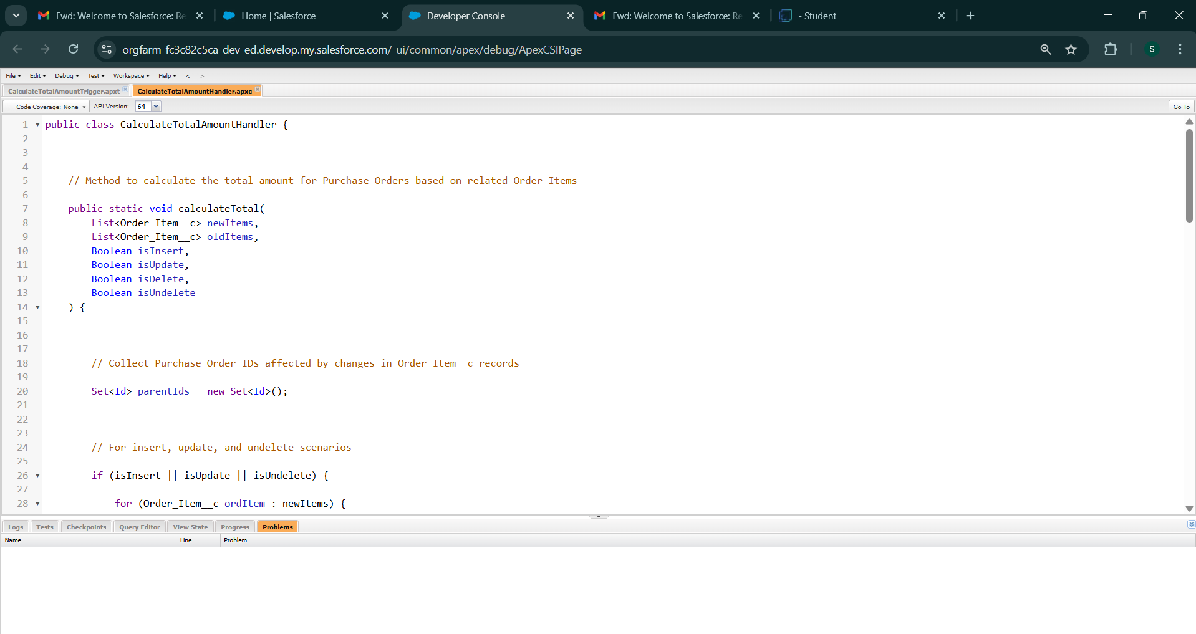

public class CalculateTotalAmountHandler {

// Method to calculate the total amount for Purchase Orders based on related Order Items

public static void calculateTotal(

List<Order_Item__c> newItems,

List<Order_Item__c> oldItems,

Boolean isInsert,

Boolean isUpdate,

Boolean isDelete,

Boolean isUndelete

) {

// Collect Purchase Order IDs affected by changes in Order_Item__c records

Set<Id> parentIds = new Set<Id>();

// For insert, update, and undelete scenarios

if (isInsert || isUpdate || isUndelete) {

for (Order_Item__c ordItem : newItems) {

parentIds.add(ordItem.Purchase_Order__c);

}

}

// For update and delete scenarios

if (isUpdate || isDelete) {

for (Order_Item__c ordItem : oldItems) {

parentIds.add(ordItem.Purchase_Order__c);

}

}

// Calculate the total amounts for affected Purchase Orders

Map<Id, Decimal> purchaseToUpdateMap = new Map<Id, Decimal>();

if (!parentIds.isEmpty()) {

// Perform an aggregate query to sum the Amount__c for each Purchase Order

List<AggregateResult> aggrList = [

SELECT Purchase_Order__c, SUM(Amount__c)

FROM Order_Item__c

GROUP BY Purchase_Order__c

];

// Map the result to Purchase Order IDs

for (AggregateResult aggr : aggrList) {

Id purchaseOrderId = (Id)aggr.get('Purchase_Order_Id__c');

Decimal totalAmount = (Decimal)aggr.get('totalAmount');

purchaseToUpdateMap.put(purchaseOrderId, totalAmount);

}

// Prepare Purchase Order records for update

List<Purchase_Order__c> purchaseToUpdate = new List<Purchase_Order__c>();

for (Id purchaseOrderId : purchaseToUpdateMap.keySet()) {

Purchase_Order__c purchaseOrder = new Purchase_Order__c(Id = purchaseOrderId, Total_Order_cost__c = purchaseToUpdateMap.get(purchaseOrderId));

purchaseToUpdate.add(purchaseOrder);

}

// Update Purchase Orders if there are any changes

if (!purchaseToUpdate.isEmpty()) {

update purchaseToUpdate;

}

}

}

}

**Create a Purchase Orders based on Suppliers(Summary) Report**

1.  Click App Launcher

2.  Select Medical Inventory Management App

3.  Click on Reports tab

4.  Click on New Report.

5.  Click the report type as Purchase Orders Click Start report.

7. Customize your report, in group rows select – Supplier ID, Purchase Order: Purchase Order ID, for columns Order Count, Total Order Cost  (In this way we are making a Summary Report).

8.  Click save and run

9.  Give report name – Purchase Orders based on Suppliers.

10.  Click Save

NOTE: In this report you can see your all record of the object you selected for reporting

(What you selects in “Select a report type option”)

View Report

1.   Click on App Launcher on the left side of the screen.

2.   Search Medical Inventory Management App & click on it.

3.   Click on Reports Tab.

4.   Click on  Purchase Orders based on Suppliers and see records.

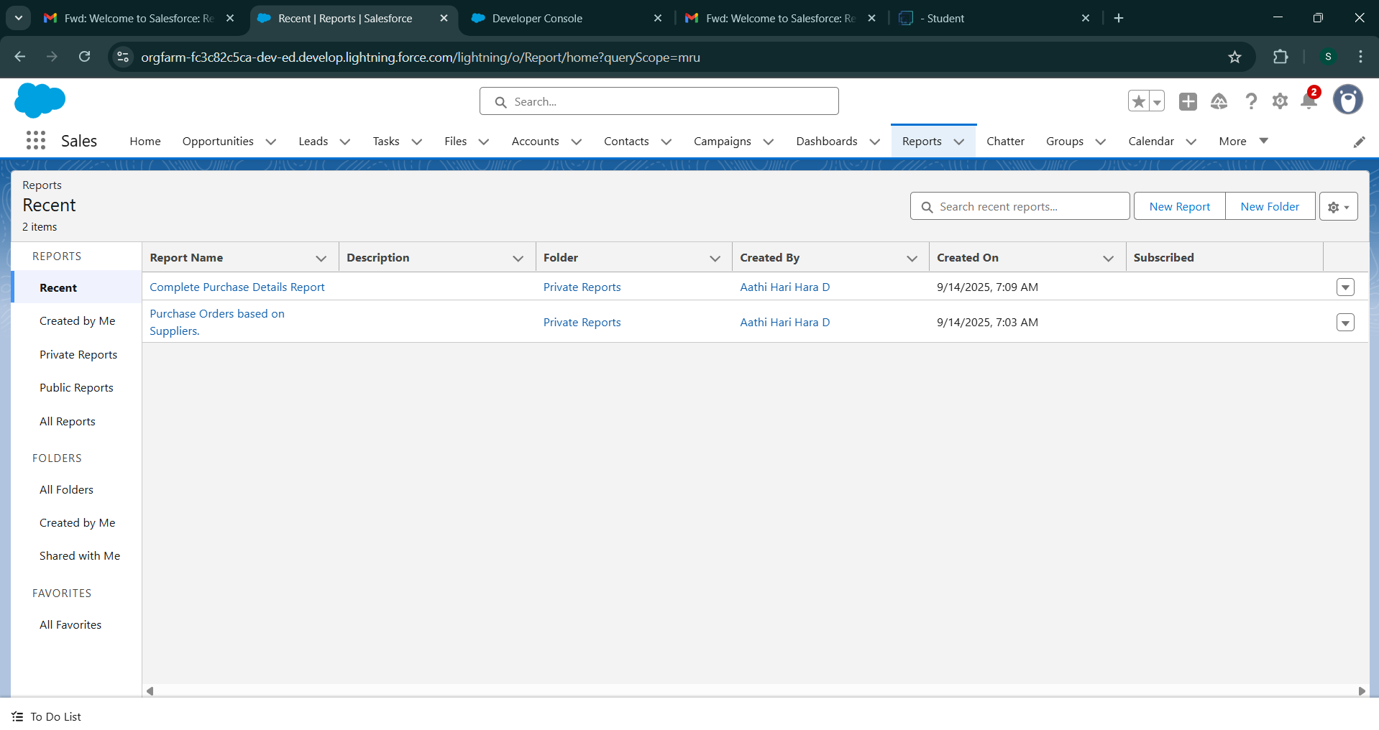

**Create a Complete Purchase Details Report**

1.  Click App Launcher

2.  Select Medical Inventory Management App

3.  Click on Reports tab

4.  Click on New Report.

5.  Click the report type as Purchase Orders with Order Items and Product ID >> Click Start report.

6.  Click on Filters and select as follows and click on Apply

7. Customize your report, in group rows select – Supplier ID, Actual Delivery Date,  Purchase Order: Purchase Order ID, for columns Product ID : Product ID,  Product ID : Product Name, Order Count, Quantity Received, Amount  (In this way we are making a Summary Report).

8.  Click save and run

9.  Give report name – Complete Purchase Details Report

10.  Click Save

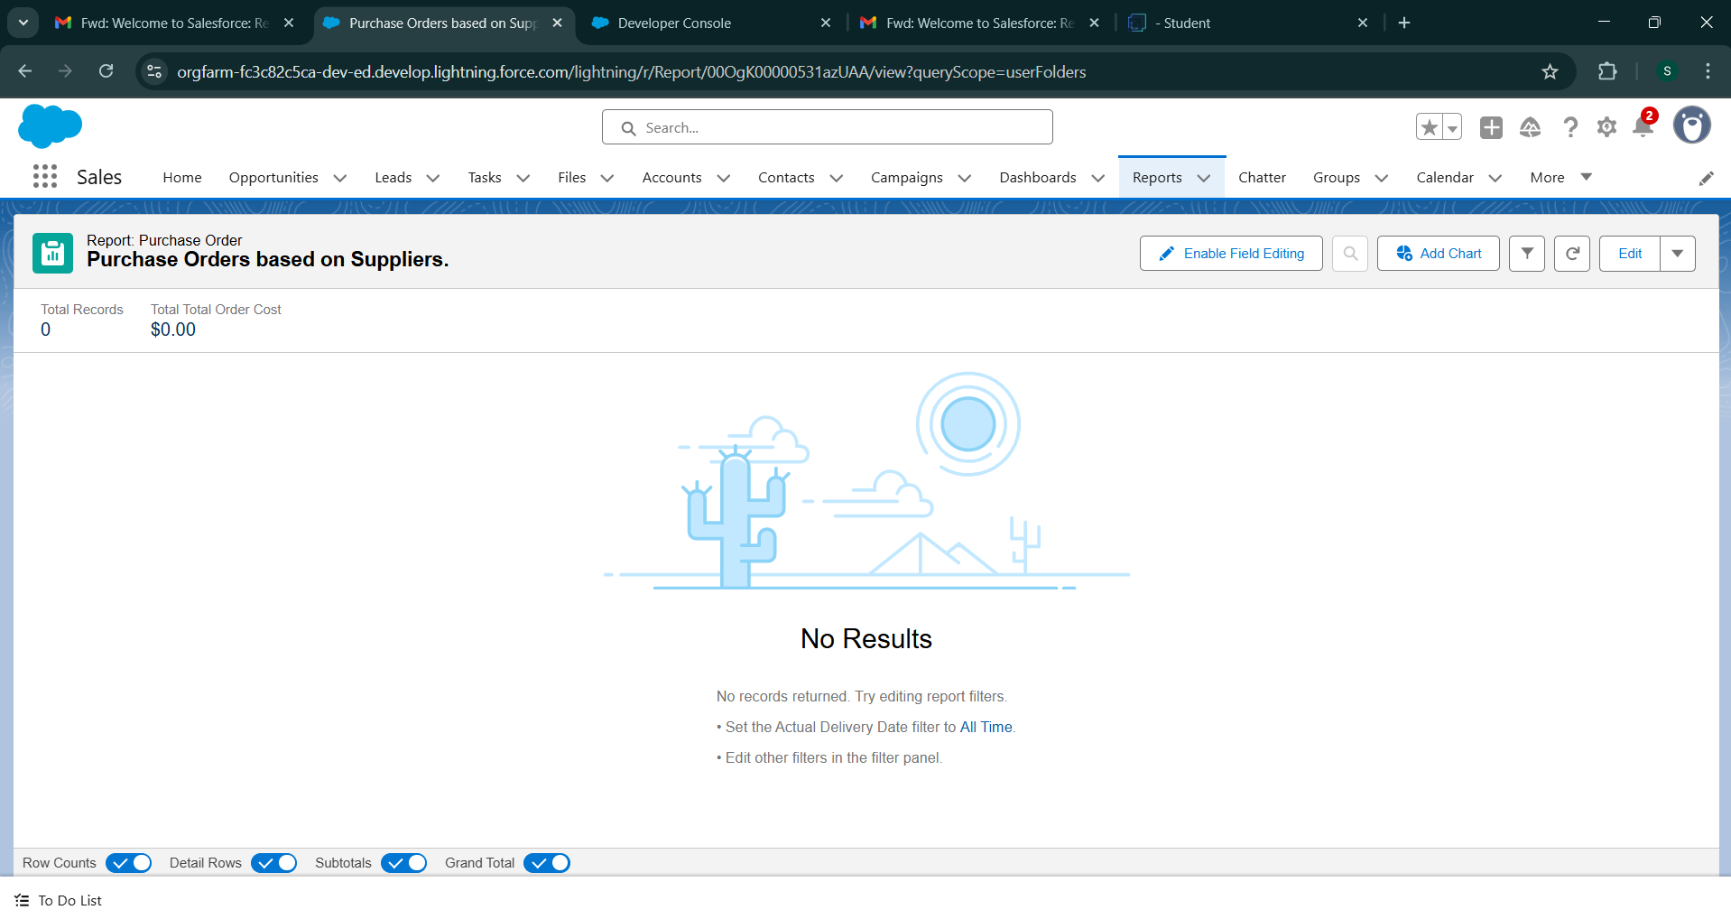

**Create Dashboard**

1. Click on the Dashboards tab from the Medical Inventory Management application.
2. Click on the new dashboard.
3. Give name - Medical Inventory DashBoard
4. Click create
5. Click on +widget
6. Select the  Purchase Orders based on Suppliers   Report
7. For the data visualization select any of the charts, tables etc. as per your choice/requirement
8. Click add.
9. Click save.

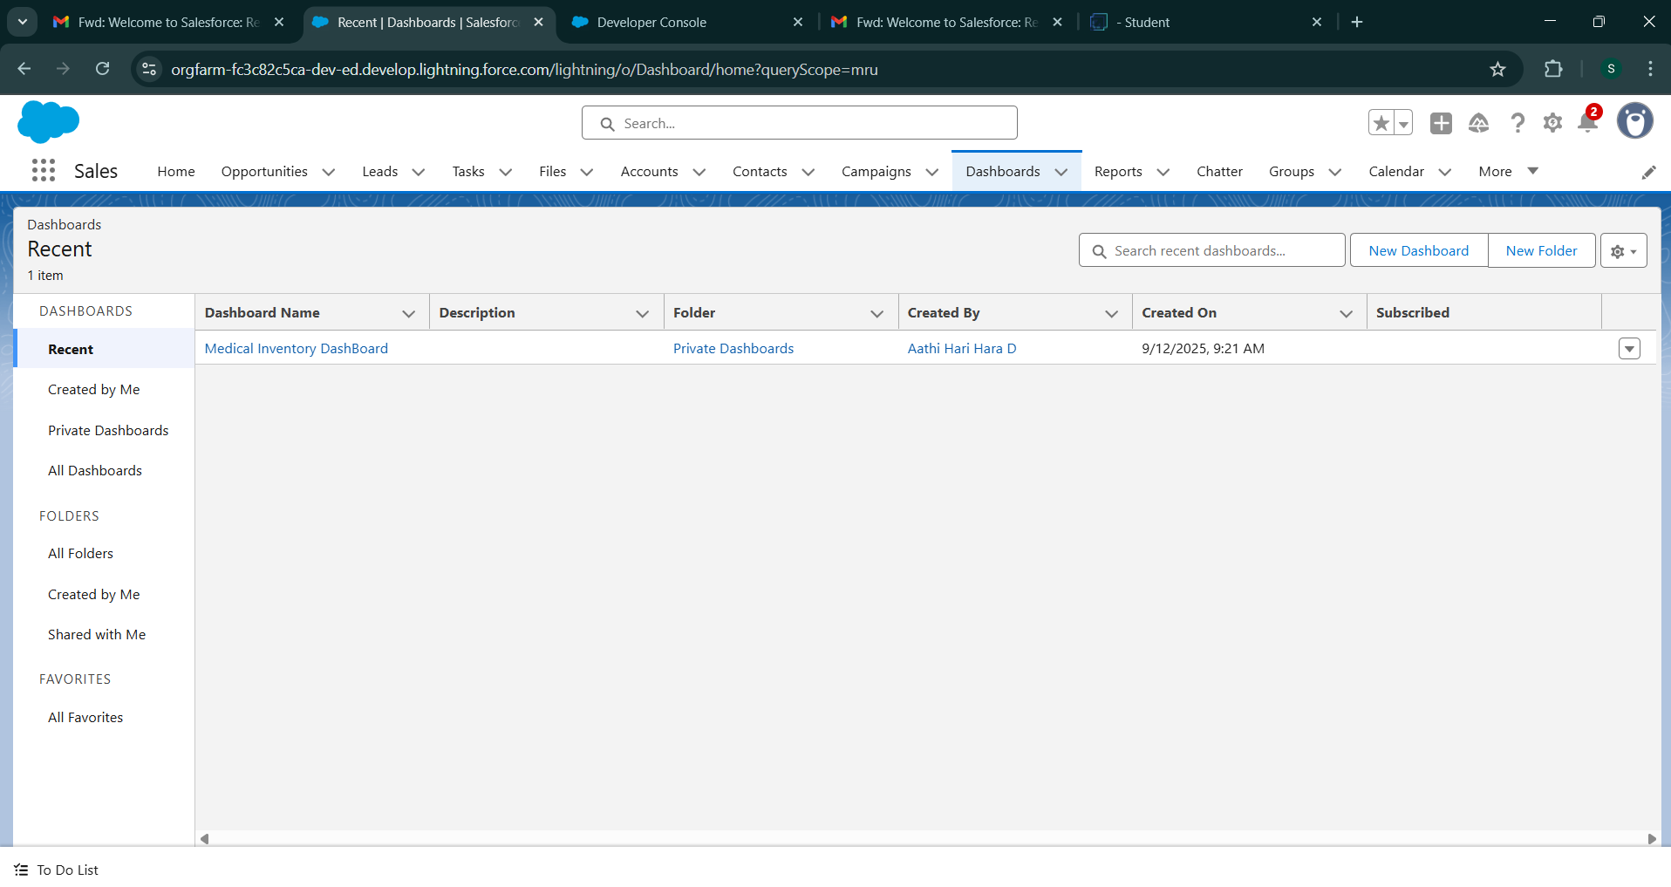

**View Dashboard**

1.   Click on App Launcher on the left side of the screen.

2.   Search Medical Inventory Management & click on it.

3.   Click on Dashboard Tab.

4.   Click on Medical Inventory DashBoard see graph view of records

